Table of Contents

1. System Requirement Specification 11

1.1 Functional Requirements 11

1.1.1 Manage Brand [MB] 11

1.1.2 Manage Category [MC] 11

1.1.3 Manage Product [MP] 11

1.1.4 Manage Orders [MO] 12

2.1.1 Generate Orders Report [GOR] 12

2.1.2 Manage Setting [MS] 12

2.2 Non-Functional Requirements 12

2.2.1 Performance Requirements 12

2.2.2 Safety and Security Requirements 13

2.2.3 Reliability 13

2.2.4 Other Software Quality Attributes 13

2.2.4.1 Usability 13

2.2.4.2 Availability 13

3. System Design 14

3.1 UML Diagram 14

3.2 High Level Use Case Diagram of Stock Management System 15

3.2.1 Use Case Diagram 16

3.2.2 Collaboration Diagram 16

3.2.3 Sequence Diagram 16

3.2.4 Activity Diagram 16

3.3 Login Dashboard 17

3.3.1 Use Case Diagram of Login 17

3.3.2 Collaboration Diagram of Login 18

3.3.3 Sequence Diagram of Login 18

3.3.4 Activity Diagram of Login 19

3.4 Manage Brand [MB] 20

3.4.1 Use Case Diagram of Manage Brand 20

3.4.2 Collaboration Diagram of Manage Brand 21

3.4.2.1 MB – 1 Add Brand Collaboration Diagram of Manage Brand 21

3.4.2.2 MB – 2 Edit Brand Collaboration Diagram of Manage Brand 21

3.4.2.3 MB – 3 Remove Brand Collaboration Diagram of Manage Brand 22

3.4.2.4 MB – 4 Display Brand Collaboration Diagram of Manage Brand 22

3.4.3 Sequence Diagram of Manage Brand 23

3.4.3.1 MB – 1 Add Brand Sequence Diagram of Manage Brand 23

3.4.3.2 MB – 2 Edit Brand Sequence Diagram of Manage Brand 23

3.4.3.3 MB – 3 Remove Brand Sequence Diagram of Manage Brand 24

3.4.3.4 MB – 4 Display Brand Sequence Diagram of Manage Brand 24

3.4.4 Activity Diagram of Manage Brand 25

3.4.4.1 MB – 1 Add Brand Activity Diagram of Manage Brand 25

3.4.4.2 MB – 2 Edit Brand Activity Diagram of Manage Brand 26

3.4.4.3 MB – 3 Remove Brand Activity Diagram of Manage Brand 27

3.4.4.4 MB – 4 Display Brand Activity Diagram of Manage Brand 28

3.5 Manage Category [MC] 29

3.5.1 Use Case Diagram of Manage Category 29

3.5.2 Collaboration Diagram of Manage Category 30

3.5.2.1 MC – 1 Add Category Collaboration Diagram of Manage Category 30

3.5.2.2 MC – 2 Edit Brand Collaboration Diagram of Manage Category 30

3.5.2.3 MC – 3 Remove Brand Collaboration Diagram of Manage Category 31

3.5.2.4 MC – 4 Display Brand Collaboration Diagram of Manage Category 31

3.5.3 Sequence Diagram of Manage Category 32

3.5.3.1 MC – 1 Add Category Sequence Diagram of Manage Category 32

3.5.3.2 MC – 2 Edit Category Sequence Diagram of Manage Category 32

3.5.3.3 MC – 3 Remove Category Sequence Diagram of Manage Category 33

3.5.3.4 MC – 4 Display Category Sequence Diagram of Manage Category 33

3.5.4 Activity Diagram of Manage Category 34

3.5.4.1 MC – 1 Add Category Activity Diagram of Manage Category 34

3.5.4.2 MC – 2 Edit Category Activity Diagram of Manage Category 35

3.5.4.3 MC – 3 Remove Category Activity Diagram of Manage Category 36

3.5.4.4 MC – 4 Display Category Activity Diagram of Manage Category 37

3.6 Manage Product [MP] 38

3.6.1 Use Case Diagram of Manage Product 38

3.6.2 Collaboration Diagram of Manage Product 39

3.6.2.1 MP – 1 Add Product Collaboration Diagram of Manage Product 39

3.6.2.2 MP – 2 Edit Product Collaboration Diagram of Manage Product 39

3.6.2.3 MP – 3 Remove Product Collaboration Diagram of Manage Product 40

3.6.2.4 MP – 4 Display Product Collaboration Diagram of Manage Product 40

3.6.3 Sequence Diagram of Manage Product 41

3.6.3.1 MP – 1 Add Product Sequence Diagram of Manage Product 41

3.6.3.2 MP – 2 Edit Product Sequence Diagram of Manage Product 41

3.6.3.3 MP – 3 Remove Product Sequence Diagram of Manage Product 42

3.6.3.4 MP – 4 Display Product Sequence Diagram of Manage Product 42

3.6.4 Activity Diagram of Manage Product 43

3.6.4.1 MP – 1 Add Product Activity Product of Manage Product 43

3.6.4.2 MP – 2 Edit Product Activity Product of Manage Product 44

3.6.4.3 MP – 3 Remove Product Activity of Manage Product 45

3.6.4.4 MP – 4 Display Product Activity Diagram of Manage Product 46

3.7 Manage Orders [MO] 47

3.7.1 Use Case Diagram of Manage Orders 47

3.7.2 Collaboration Diagram of Manage Orders 48

3.7.2.1 MO – 1 Add Orders Collaboration Diagram of Manage Orders 48

3.7.2.2 MO – 2 Edit Orders Collaboration Diagram of Manage Orders 48

3.7.2.3 MO – 3 Remove Orders Collaboration Diagram of Manage Orders 49

3.7.2.4 MO – 4 Display Orders Collaboration Diagram of Manage Orders 49

3.7.2.5 MO – 5 Print Orders Collaboration Diagram of Manage Orders 50

3.7.3 Sequence Diagram of Manage Orders 51

3.7.3.1 MO – 1 Add Orders Sequence Diagram of Manage Orders 51

3.7.3.2 MP – 2 Edit Orders Sequence Diagram of Manage Orders 51

3.7.3.3 MP – 3 Remove Orders Sequence Diagram of Manage Orders 52

3.7.3.4 MP – 4 Display Orders Sequence Diagram of Manage Orders 52

3.7.3.5 MP – 5 Print Orders Sequence Diagram of Manage Orders 53

3.7.4 Activity Diagram of Manage Orders 54

3.7.4.1 MO – 1 Add Orders Activity Diagram of Manage Orders 54

3.7.4.2 MO – 2 Edit Orders Activity Diagram of Manage Orders 55

3.7.4.3 MO – 3 Remove Orders Activity Diagram of Manage Orders 56

3.7.4.4 MO – 4 Display Orders Activity Diagram of Manage Orders 57

3.7.4.5 MO – 5 Print Orders Bill Activity Diagram of Manage Orders 58

3.8 Generate Orders Report [GOR] 59

3.8.1 Use Case Diagram of Generate Orders Report 59

3.8.2 Collaboration Diagram of Generate Orders Report 60

3.8.3 Sequence Diagram of Generate Orders Report 60

3.8.4 Activity Diagram of Generate Orders Report 61

3.10 Entity Relationship Diagram 62

3.10.1 List of Entities 62

3.10.2 Relationship with Entities 63

3.10.2.1 Product – Brands 63

3.10.2.2 Product – Category 63

3.10.2.3 Orders Item – Product 63

3.10.2.4 Orders Item – Orders 63

3.10.3 ER – Diagram 64

3.10.4 Data Dictionary 65

3.10.4.1 Table: Users 65

3.10.4.2 Table: Brand 65

3.10.4.3 Table: Category 65

3.10.4.4 Table: Product 65

3.10.4.5 Table: Orders 66

3.10.4.6 Table: Orders Item 66

3.11 Wireframe Design 67

3.11.1 Login 67

3.11.2 Dashboard 67

3.11.3 Manage Brands 68

3.11.3.1 Add Brands 68

3.11.3.2 Edit Brands 68

3.11.3.3 Remove Brands 69

3.11.3.4 Display Brands 69

3.11.4 Manage Category 70

3.11.4.1 Add Category 70

3.11.4.2 Edit Category 70

3.11.4.3 Remove Category 71

3.11.4.4 Display Category 71

3.11.5 Manage Product 72

3.11.5.1 Add Product 72

3.11.5.2 Edit Product 72

3.11.5.3 Remove Product 73

3.11.5.4 Display Product 73

3.11.6 Manage Orders 74

3.11.6.1 Add Orders 74

3.11.6.2 Edit Orders 75

3.11.6.3 Remove Orders 76

3.11.6.4 Display Orders 76

3.11.6.5 Payment 77

3.11.6.6 Print Orders Bill 77

3.11.7 Generate Orders Report 78

3.11.7.1 Generate Orders Report Form 78

3.11.7.2 Layout of Report 78

3.11.8 Setting 79

4 Implementation 80

4.1 Screenshots of Final System 80

4.1.1 User Login 80

4.1.2 Dashboard 80

4.1.3 Manage Brands 81

4.1.3.1 Add Brand 81

4.1.3.2 Edit Brand 81

4.1.3.3 Remove Brand 81

4.1.3.4 Display Brands 82

4.1.4 Manage Category 82

4.1.4.1 Add Category 82

4.1.4.2 Edit Category 82

4.1.4.3 Remove Category 83

4.1.4.4 Display Category 83

4.1.5 Manage Products 84

4.1.5.1 Add Product 84

4.1.5.2 Edit Product 85

4.1.5.3 Remove Product 86

4.1.5.4 Display Products 86

4.1.6 Manage Orders 87

4.1.6.1 Add Orders 87

4.1.6.2 Edit Orders 88

4.1.6.3 Remove Orders 89

4.1.6.4 Display Orders 89

4.1.7 Generate Orders Report 89

4.1.8 Setting 90

5 References 91

**List of Tables**

Table 1 Functional Requirement of Manage Brand 11

Table 2 Functional Requirement of Manage Category 11

Table 3 Functional Requirement of Manage Product 11

Table 4 Functional Requirement of Manage Orders 12

Table 5 Function Requirement of Generate Orders Report 12

Table 6 Functional Requirements of Manage Setting 12

Table 7 Performance Requirement of the system 13

Table 8 Safety and Security Requirements 13

Table 9 Reliability Requirements of the system 13

Table 10 Symbols used in UML Diagram 14

Table 11 Table: Users 65

Table 12 Table: Brand 65

Table 13 Table: Category 65

Table 14 Table: Product 65

Table 15 Table: Orders 66

Table 16 Table: Orders Item 66

**List of Figures**

Figure 1 High Level Use Case Diagram of Stock Management System 15

Figure 2 Use Case Diagram of Login Dashboard 17

Figure 3 Collaboration Diagram of Login 18

Figure 4 Sequence Diagram of Login 18

Figure 5 Activity Diagram of Login 19

Figure 6 Use Case Diagram of Manage Brand 20

Figure 7 Collaboration Diagram of Add Brand 21

Figure 8 Collaboration Diagram of Edit Brand 21

Figure 9 Collaboration Diagram of Remove Brand 22

Figure 10 Collaboration Diagram of Display Brand 22

Figure 11 Sequence Diagram of Add Brand 23

Figure 12 Sequence Diagram of Edit Brand 23

Figure 13 Sequence Diagram of Remove Brand 24

Figure 14 Sequence Diagram of Display Brand 24

Figure 15 Activity Diagram of Add Brand 25

Figure 16 Activity Diagram of Edit Brand 26

Figure 17 Activity Diagram of Remove Brand 27

Figure 18 Activity Diagram of Display Brand 28

Figure 19 Use Case Diagram of Manage Category 29

Figure 20 Collaboration Diagram of Add Category 30

Figure 21 Collaboration Diagram of Edit Category 30

Figure 22 Collaboration Diagram of Remove Brand 31

Figure 23 Collaboration Diagram of Display Brand 31

Figure 24 Sequence Diagram of Add Category 32

Figure 25 Sequence Diagram of Edit Category 32

Figure 26 Sequence Diagram of Remove Category 33

Figure 27 Sequence Diagram of Display Category 33

Figure 28 Activity Diagram of Add Category 34

Figure 29 Activity Diagram of Edit Category 35

Figure 30 Activity Diagram of Remove Category 36

Figure 31 Activity Diagram of Display Category 37

Figure 32 Use Case Diagram of Manage Product 38

Figure 33 Collaboration Diagram of Add Product 39

Figure 34 Collaboration Diagram of Edit Product 39

Figure 35 Collaboration Diagram of Remove Product 40

Figure 36 Collaboration Diagram of Display Product 40

Figure 37 Sequence Diagram of Add Product 41

Figure 38 Sequence Diagram of Edit Product 41

Figure 39 Sequence Diagram of Remove Product 42

Figure 40 Sequence Diagram of Display Product 42

Figure 41 Activity Diagram of Add Product 43

Figure 42 Activity Diagram of Edit Product 44

Figure 43 Activity Diagram of Remove Product 45

Figure 44 Activity Diagram of Display Product 46

Figure 45 Use Case Diagram of Manage Orders 47

Figure 46 Collaboration Diagram of Add Order 48

Figure 47 Collaboration Diagram of Edit Order 48

Figure 48 Collaboration Diagram of Remove Order 49

Figure 49 Collaboration Diagram of Display Orders 49

Figure 50 Collaboration Diagram of Print Orders 50

Figure 51 Sequence Diagram of Add Orders 51

Figure 52 Sequence Diagram of Edit Orders 51

Figure 53 Sequence Diagram of Remove Orders 52

Figure 54 Sequence Diagram of Display Orders 52

Figure 55 Sequence Diagram of Print Orders 53

Figure 56 Activity Diagram of Add Orders 54

Figure 57 Activity Diagram of Edit Orders 55

Figure 58 Activity Diagram of Remove Orders 56

Figure 59 Activity Diagram of Display Orders 57

Figure 60 Activity Diagram of Print Orders Bill 58

Figure 61 Use Case Diagram of Generate Orders Report 59

Figure 62 Collaboration Diagram of Generate Report 60

Figure 63 Sequence Diagram of Generate Orders Report 60

Figure 64 Activity Diagram of Generate Orders Reports 61

Figure 65 List of Entities 62

Figure 66 Product - Brands Entity Relationship 63

Figure 67 Product – Category Entity Relationship 63

Figure 68 Orders Item – Product Entity Relationship 63

Figure 69 Orders Item - Orders Entity Relationship 63

Figure 70 Entity Relationship Diagram ERD 64

Figure 77 Wireframe Design of Login 67

Figure 78 Wireframe Design of Dashboard 67

Figure 79 Wireframe Design for Add Brands 68

Figure 80 Wireframe Design for Edit Brands 68

Figure 81 Wireframe Design for Remove Brand 69

Figure 82 Wireframe Design for Display Brands 69

Figure 83 Wireframe Design for Add Category 70

Figure 84 Wireframe Design for Edit Category 70

Figure 85 Wireframe Design for Remove Category 71

Figure 86 Wireframe Design for Display Category 71

Figure 87 Wireframe Design for Add Product 72

Figure 88 Wireframe Design for Edit Product 72

Figure 89 Wireframe Design for Remove Product 73

Figure 90 Wireframe Design for Display Product 73

Figure 91 Wireframe Design for Add Orders 74

Figure 92 Wireframe Design for Edit Orders 75

Figure 93 Wireframe Design for Remove Orders 76

Figure 94 Wireframe Design for Display Orders 76

Figure 95 Wireframe Design for Payment 77

Figure 96 Wireframe Design for Print Order Bill 77

Figure 97 Wireframe Design for Generate Order Report Form 78

Figure 98 Wireframe Design for Layout of Report 78

Figure 99 Wireframe Design for Setting 79

Figure 100 Screenshots of Login 80

Figure 101 Screenshots of Dashboard 80

Figure 102 Screenshots of Add Brand 81

Figure 103 Screenshots of Edit Brand 81

Figure 104 Screenshots of Remove Brand 81

Figure 105 Screenshots of Manage Brands 82

Figure 106 Screenshots of Add Category 82

Figure 107 Screenshots of Edit Category 82

Figure 108 Screenshots of Remove Brand 83

Figure 109 Screenshots of Display Category 83

Figure 110 Screenshots of Add Product 84

Figure 111 Screenshots of Edit Product 85

Figure 112 Screenshots of Edit Product 85

Figure 113 Screenshots of Remove Product 86

Figure 114 Screenshots of Display Products 86

Figure 115 Screenshots of Add Orders 87

Figure 116 Screenshots of Edit Orders 88

Figure 117 Screenshots of Remove Orders 89

Figure 118 Screenshots of Display Orders 89

Figure 119 Screenshots of Generate Report Form 89

Figure 120 Screenshots of Generate Report Layout 90

Figure 121 Screenshots of Setting 90

# System Requirement Specification

## Functional Requirements

Functional requirements define a specific behavior or function of a system. This section **Function Requirements** contains the specification of functional requirement of the system. All this functional requirements can be traced by using tractability matrix. Below tables are the lists of functional requirements.

### Manage Brand [MB]

|  |  |
| --- | --- |
| **Requirement ID** | **Requirement Description** |
| MB - 1 | The system must allow the admin to ***“add”*** the brand description. |
| MB - 2 | The system must allow the admin to ***“update”*** the selected brand description. |
| MB - 3 | The system must allow the admin to ***“remove”*** the selected brand. |
| MB - 4 | The system should display all the brand information in table layout. |

Table Functional Requirement of Manage Brand

### Manage Category [MC]

|  |  |
| --- | --- |
| **Requirement ID** | **Requirement Description** |
| MC - 1 | The system must allow the admin to ***“add”*** the category description. |
| MC - 2 | The system must allow the admin to ***“update”*** the selected category description. |
| MC - 3 | The system must allow the admin to ***“remove”*** the selected category. |
| MC - 4 | The system should display all the category information in table layout. |

Table Functional Requirement of Manage Category

### Manage Product [MP]

|  |  |
| --- | --- |
| **Requirement ID** | **Requirement Description** |
| MP - 1 | The system must allow the admin to ***“add”*** the product description with image, quantity, rate, brand, and category. |
| MP - 2 | The system must allow the admin to ***“update”*** the selected product description. |
| MP - 3 | The system must allow the admin to ***“remove”*** the selected product. |
| MP - 4 | The system should display all the product information in table layout. |

Table Functional Requirement of Manage Product

### Manage Orders [MO]

|  |  |
| --- | --- |
| 1. **Requirement ID** | **Requirement Description** |
| MO - 1 | The system must allow the admin to ***“add”*** orders. |
| MO – 2 | The system should display all the orders information in table layout. |
| MO – 3 | The system must allow the admin to ***“edit”*** the selected orders information. |
| MO - 4 | The system must allow the admin to ***“remove”*** the selected orders information. |
| MO – 5 | The system must allow the admin to ***“update”*** payment information of selected orders. |
| MO – 6 | The system must allow the admin to ***“print”*** the orders bill. |

Table Functional Requirement of Manage Orders

### Generate Orders Report [GOR]

|  |  |
| --- | --- |
| **Requirement ID** | **Requirement Description** |
| GOR - 1 | The system must allow the admin to select start date and end date for the report and generate the orders report according to the date. |

Table Function Requirement of Generate Orders Report

### Manage Setting [MS]

|  |  |
| --- | --- |
| **Requirement ID** | **Requirement Description** |
| MS – 1 | The system must allow the admin to ***“update”*** username information. |
| MS – 2 | The system must allow the admin to ***“change”*** the password information. |

Table Functional Requirements of Manage Setting

## Non-Functional Requirements

A non-functional requirements is a requirements that specifies criteria of the developed system. This can be used to judge the operation of the system, rather than specific behaviors. This is contrasted with functional requirements that defines the specific behaviors or function of the system. Here are the list of identified non-functional requirements of the system.

### Performance Requirements

System must be available from all over the world at any time. Being an online stock management system, any malfunctions in the system can cause the organization to give up the stock management system. This causes should not affect the users in this system.

|  |  |
| --- | --- |
| **Requirement ID** | **Requirement Description** |
| PR – 1 | The system must respond the business operation in less than 3 seconds for user (admin). |
| PR – 2 | The system should be compatible with all modern browsers. |
| PR – 3 | The system should response the operation messages to the users within 2 seconds. |
| PR – 4 | The system should be reliable. The system should be able to generate the report for selected area with appropriate data. |

Table Performance Requirement of the system

### Safety and Security Requirements

System cannot affect, harm, damage to user or user’s property. It also cannot damage user’s computer while accessing the system over a network.

|  |  |
| --- | --- |
| **Requirement ID** | **Requirement Description** |
| SSR – 1 | The system must handle safe login and logout through session. |
| SSR – 2 | MD5 encryption technology should be used to handle the secure login for users. |
| SSR – 3 | The database should be secured from SQL injection to prevent leak or loss of confidential information. |
| SSR – 4 | The system could use SSL (Secure Socket Layer) certificates to secure the data being transmitted. |

Table Safety and Security Requirements

### Reliability

System shall be designed in a modular manner to ease in software maintenance. By designing modularly, we are able to reduce coupling allowing each module to perform a specific function.

|  |  |
| --- | --- |
| **Requirement ID** | **Requirement Description** |
| R – 1 | This program shall be reliable and provide catching of exceptions so that unintended results do not occur such as system crashes, or data validation failures. |

Table Reliability Requirements of the system

### Other Software Quality Attributes

#### Usability

* The system should have user-friendly interface.

#### Availability

* The system must be available 24/7, with no more than 20 minutes down time per day.

# System Design

## UML Diagram

UML stands for Unified Modelling Language which is used in object oriented software engineering. Although typically used in software engineering it is a rich language that can be used to model an application structures, behavior and even business processes. There are 14 UML diagram types to help you model those behavior of the system. (Nishadha, 2012)

For this project only 5 diagram of UML diagram will be used. They are Use Case, Collaboration, Sequence, Activity, and Entity Relationship Diagram.

**Symbols used in UML Diagram**

|  |  |  |
| --- | --- | --- |
| **Symbol** | **Name** | **Purpose** |
|  | Use Case | A use case defines a sequence of actions which is measurable value to an actor. |
|  | Actor | An actor is a person, organization or external system which interacts with system actions. |
|  | Object Life Line | An object lifeline represents an individual participant in the interaction. |
|  | Activation | Activation represents a period in the participant’s lifetime which is executing a unit of behavior or action within the lifetime. |
|  | Actor Life Line | Actor lifeline represents the roles played by users. |
|  | Decision | This decision symbols indicates if statement to evaluate the true/false value. |
|  | Initial Node | When the activity of the system is invoked, then the business flow of the system is started from the initial node. |
|  | Final Node | When the activity of the system flows stops then the final node is used to indicate the stop of business operation. |

Table Symbols used in UML Diagram

## High Level Use Case Diagram of Stock Management System

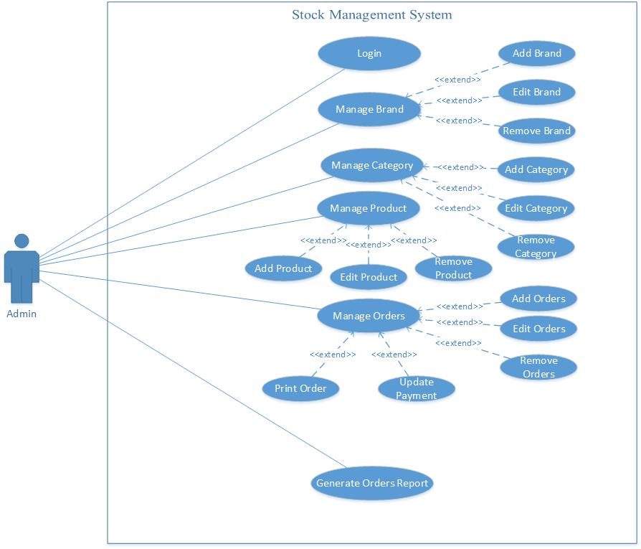

Figure High Level Use Case Diagram of Stock Management System

### Use Case Diagram

A use case is a methodology used in system analysis to identify, clarify, and organize system requirements. In this context, the term "system" refers to something being developed or operated, such as a mail-order product sales and service Web site. Use case diagrams are employed in UML (Unified Modeling Language), a standard notation for the modeling of real-world objects and systems (Rouse, WhatIs, 2015). It’s a great starting point for any project discussion, because you can easily identify the main actors involved and the main processes of the system.

### Collaboration Diagram

A collaboration diagram resembles a flowchart that portrays the roles, functionality and behavior of individual objects as well as the overall operation of the system in real time. Objects are shown as rectangles with naming labels inside. These labels are preceded by colons and may be underlined. The relationships between the objects are shown as lines connecting the rectangles. The messages between objects are shown as arrows connecting the relevant rectangles along with labels that define the message sequencing. Collaboration diagrams are best suited to the portrayal of simple interactions among relatively small numbers of objects. As the number of objects and messages grows, a collaboration diagram can become difficult to read. Several vendors offer software for creating and editing collaboration diagrams. (Rouse, TechTarget, 2007)

### Sequence Diagram

UML sequence diagrams model the flow of logic within your system in a visual manner, enabling you both to document and validate your logic, and are commonly used for both analysis and design purposes. Sequence diagrams are the most popular UML artifact for dynamic modeling, which focuses on identifying the behavior within your system. Other dynamic modeling techniques include activity diagramming, communication diagramming, timing diagramming, and interaction overview diagramming. Sequence diagrams, along with class diagrams and physical data models are in my opinion the most important design-level models for modern business application development (agilemodeling, 2016)

### Activity Diagram

Activity diagram is another important diagram in UML to describe dynamic aspects of the system. Activity diagram is basically a flow chart to represent the flow form one activity to another activity. The activity can be described as an operation of the system. So the control flow is drawn from one operation to another. This flow can be sequential, branched or concurrent. Activity diagrams deals with all type of flow control by using different elements like fork, join etc. (Points, 2016). Activity diagram is some time considered as the flow chart. Although the diagrams looks like a flow chart but it is not. It shows different flow like parallel, branched, concurrent and single. So the purposes can be described as:

* To draw the activity flow of a system.
* To describe the sequence from one activity to another.
* To describe the parallel, branched and concurrent flow of the system

## Login Dashboard

### Use Case Diagram of Login

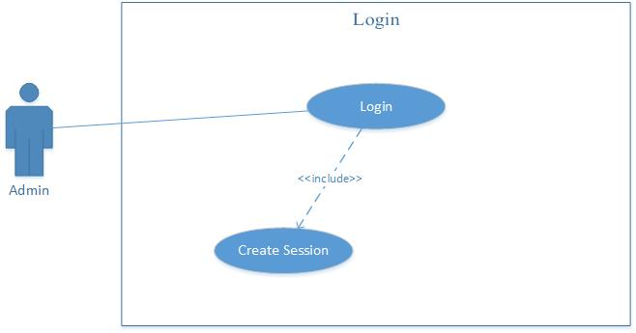

Figure Use Case Diagram of Login Dashboard

### Collaboration Diagram of Login

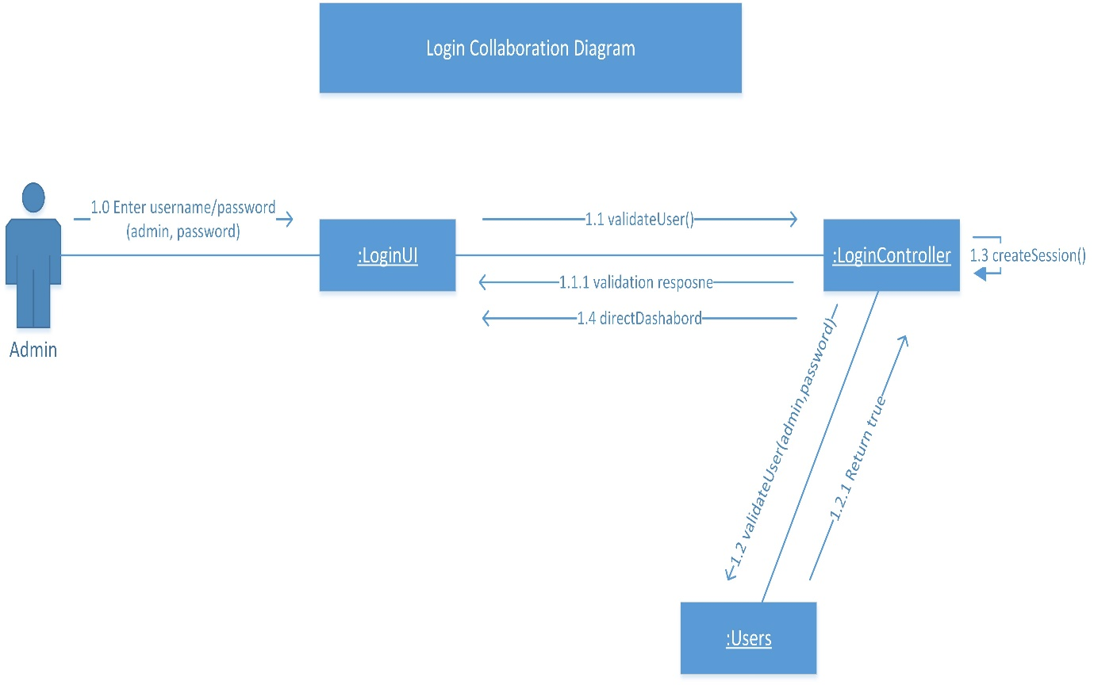

Figure Collaboration Diagram of Login

### Sequence Diagram of Login

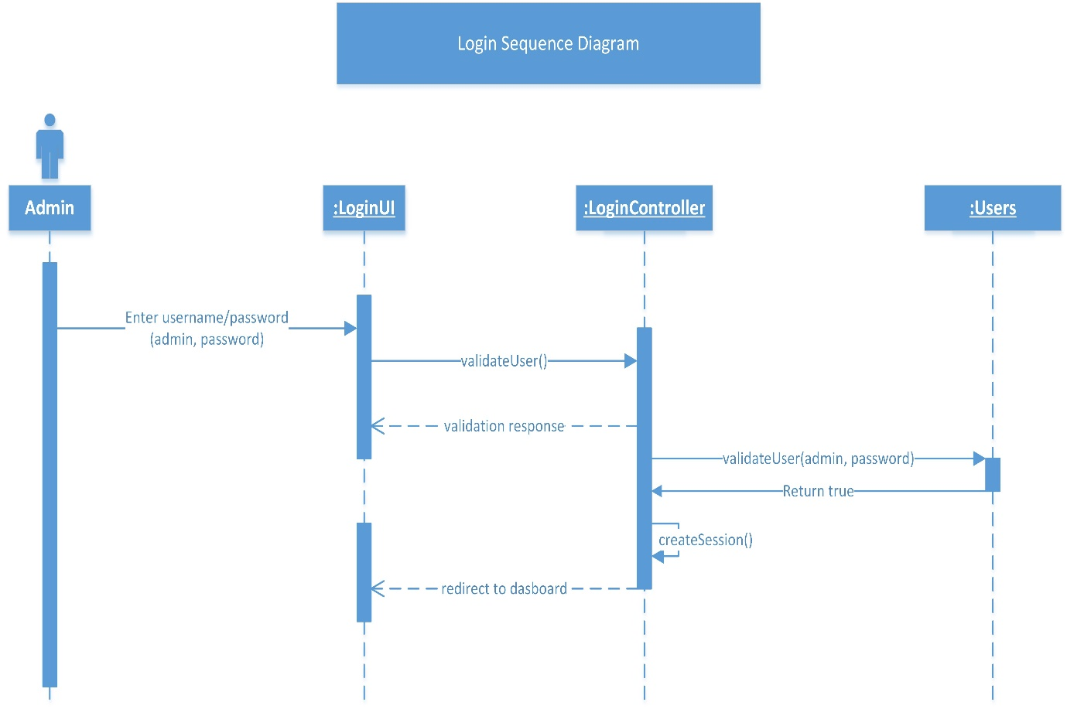

Figure Sequence Diagram of Login

### Activity Diagram of Login

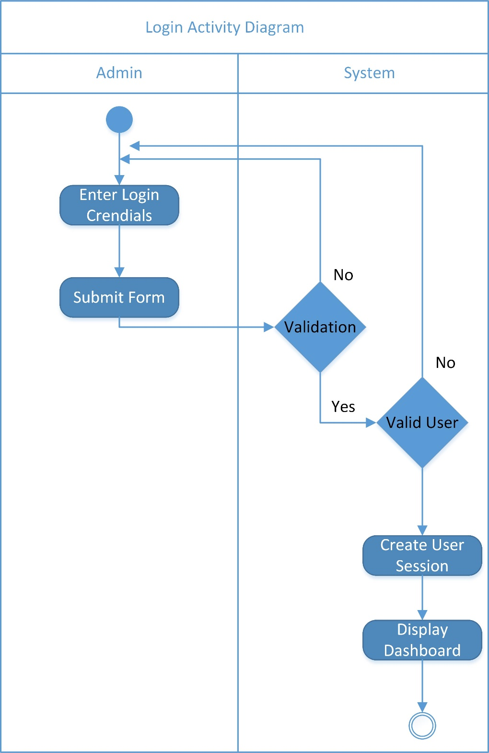

Figure Activity Diagram of Login

## Manage Brand [MB]

### Use Case Diagram of Manage Brand

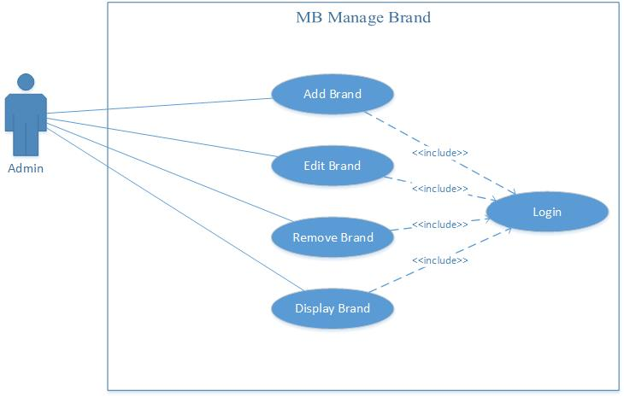

Figure Use Case Diagram of Manage Brand

### Collaboration Diagram of Manage Brand

#### MB – 1 Add Brand Collaboration Diagram of Manage Brand

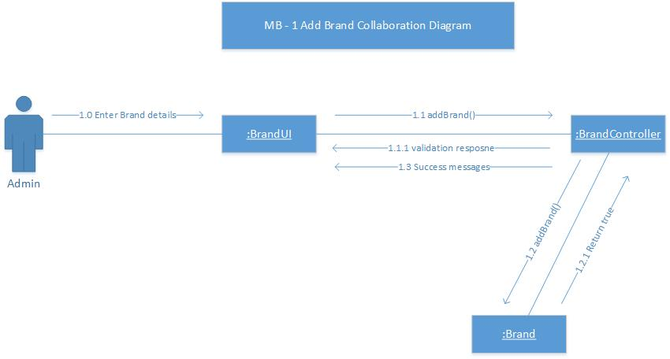

Figure Collaboration Diagram of Add Brand

#### MB – 2 Edit Brand Collaboration Diagram of Manage Brand

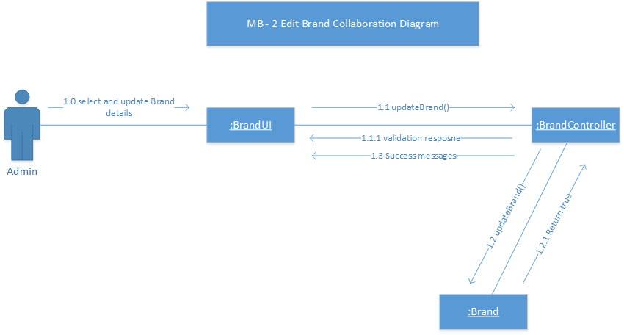

Figure Collaboration Diagram of Edit Brand

#### MB – 3 Remove Brand Collaboration Diagram of Manage Brand

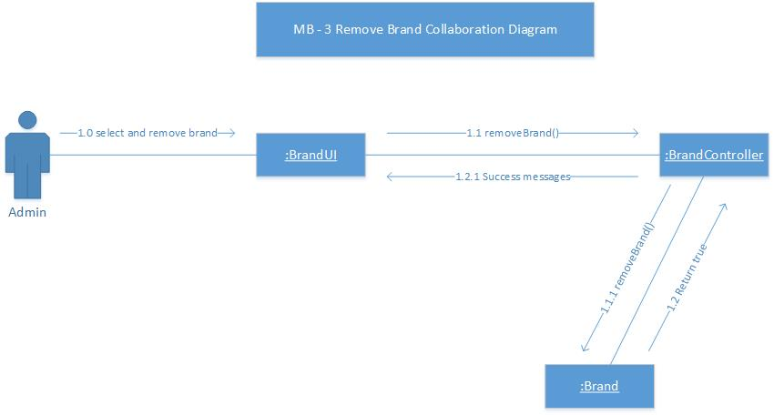

Figure Collaboration Diagram of Remove Brand

#### MB – 4 Display Brand Collaboration Diagram of Manage Brand

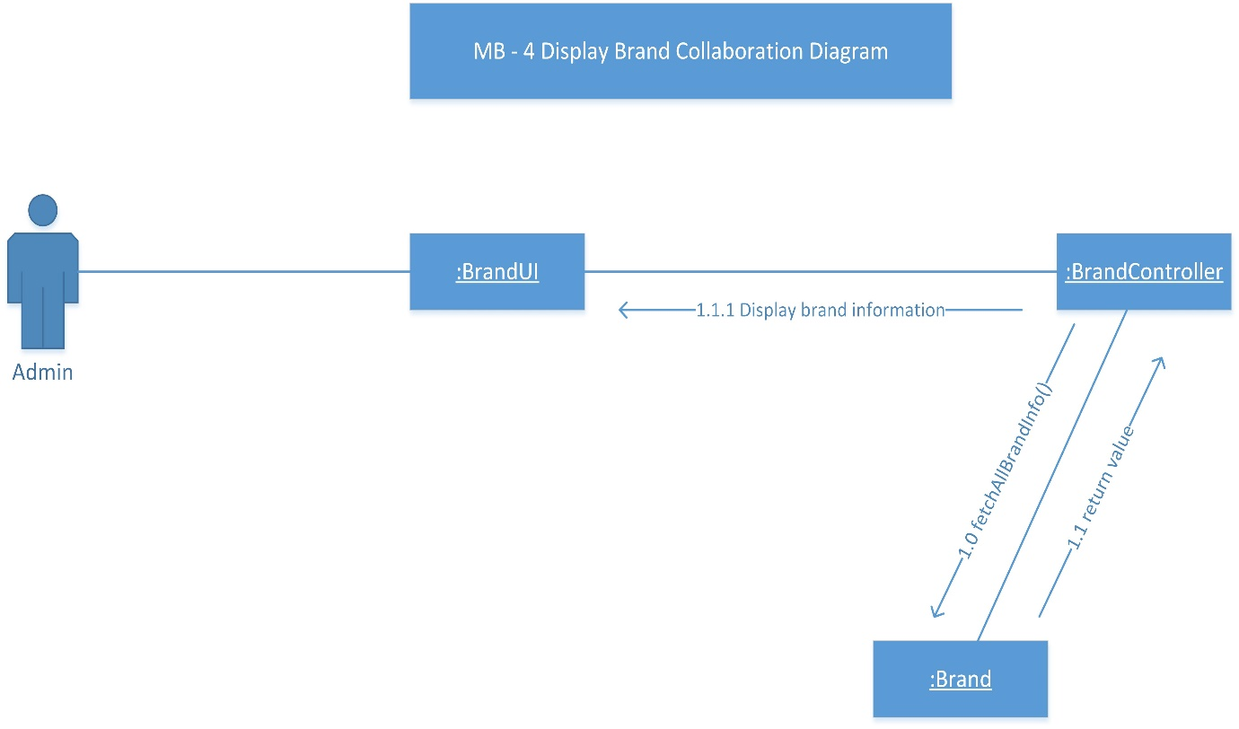

Figure Collaboration Diagram of Display Brand

### Sequence Diagram of Manage Brand

#### MB – 1 Add Brand Sequence Diagram of Manage Brand

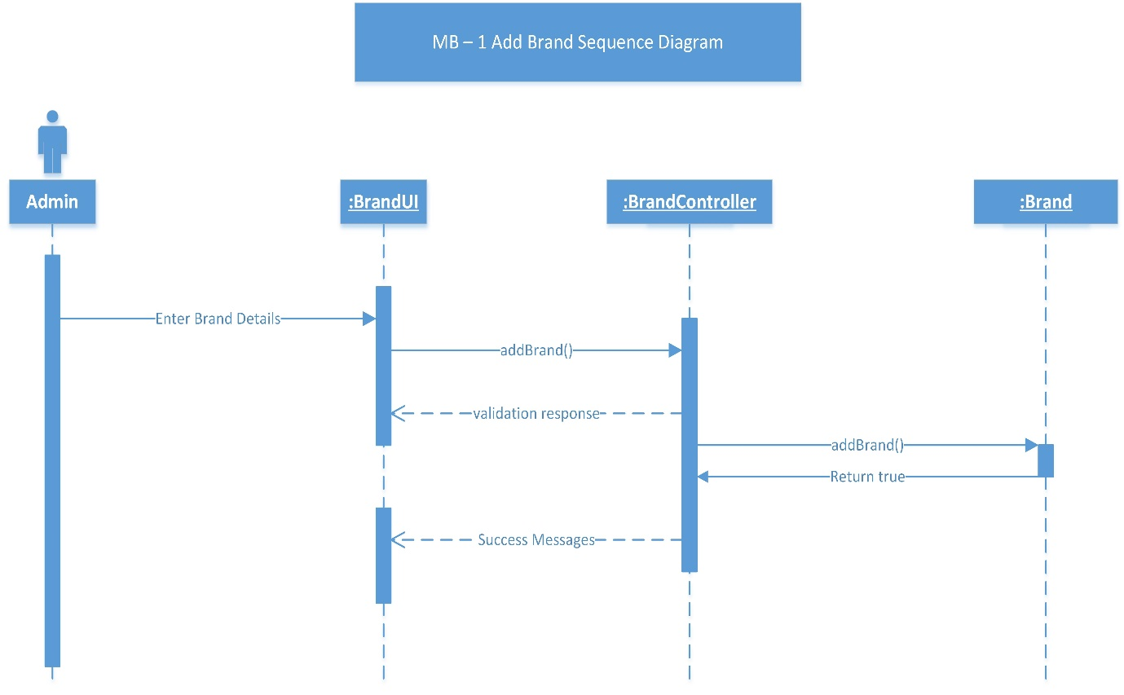

Figure Sequence Diagram of Add Brand

#### MB – 2 Edit Brand Sequence Diagram of Manage Brand

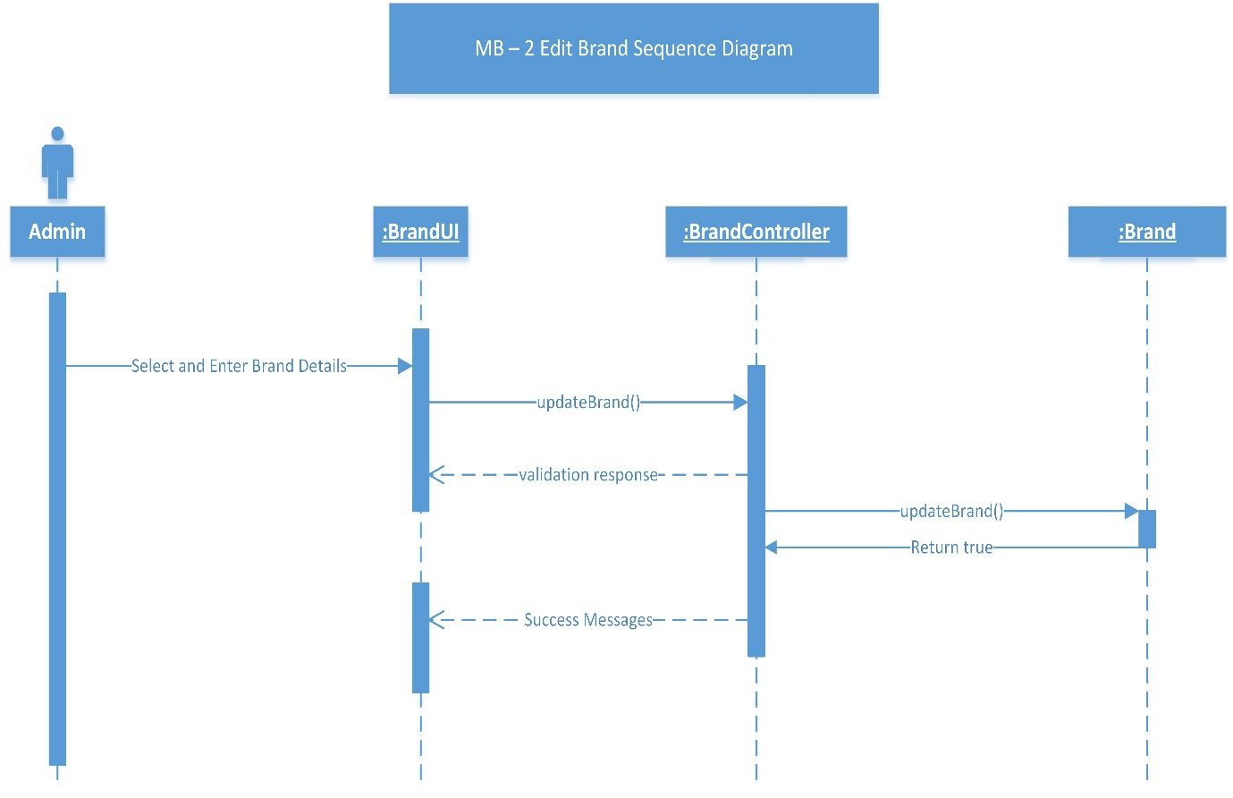

Figure Sequence Diagram of Edit Brand

#### MB – 3 Remove Brand Sequence Diagram of Manage Brand

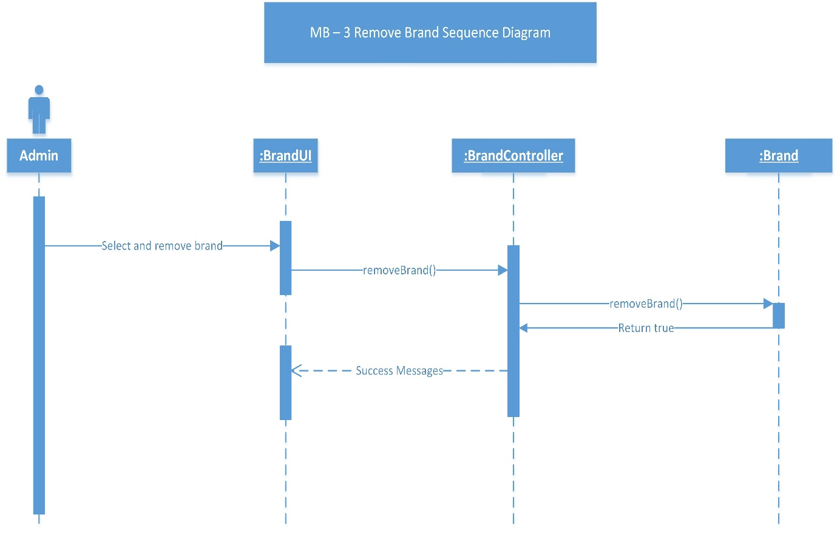

Figure Sequence Diagram of Remove Brand

#### MB – 4 Display Brand Sequence Diagram of Manage Brand

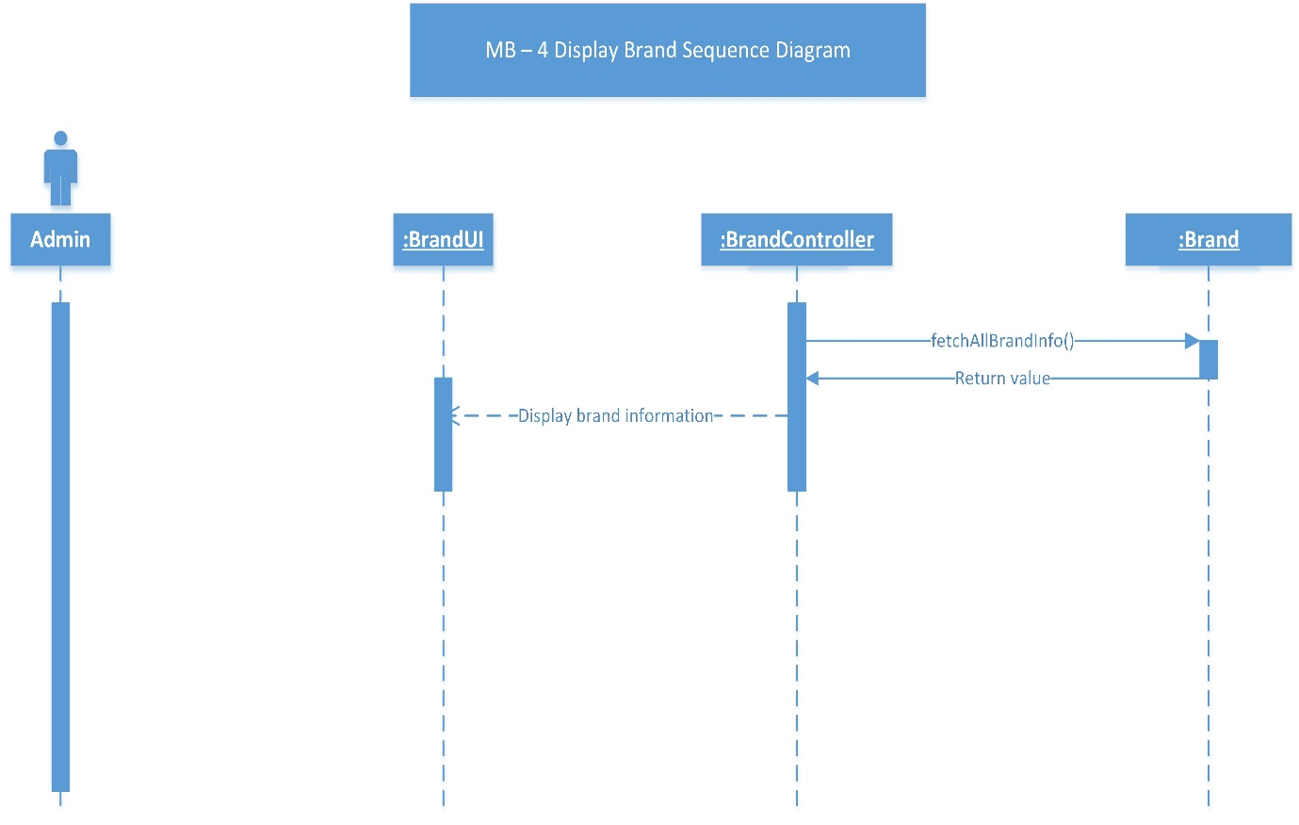

Figure Sequence Diagram of Display Brand

### Activity Diagram of Manage Brand

#### MB – 1 Add Brand Activity Diagram of Manage Brand

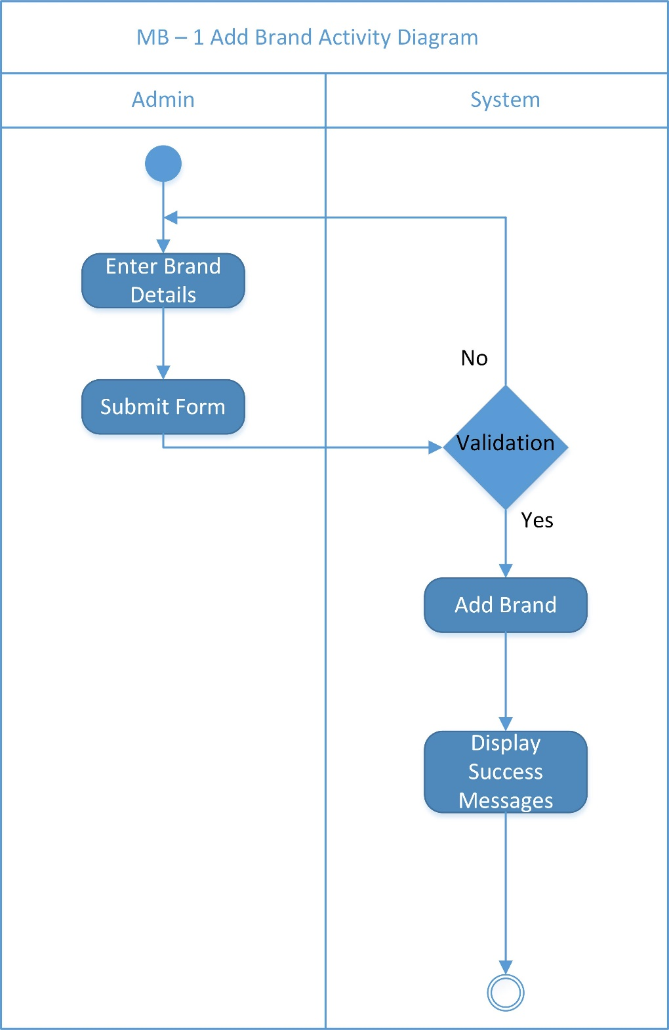

Figure Activity Diagram of Add Brand

#### MB – 2 Edit Brand Activity Diagram of Manage Brand

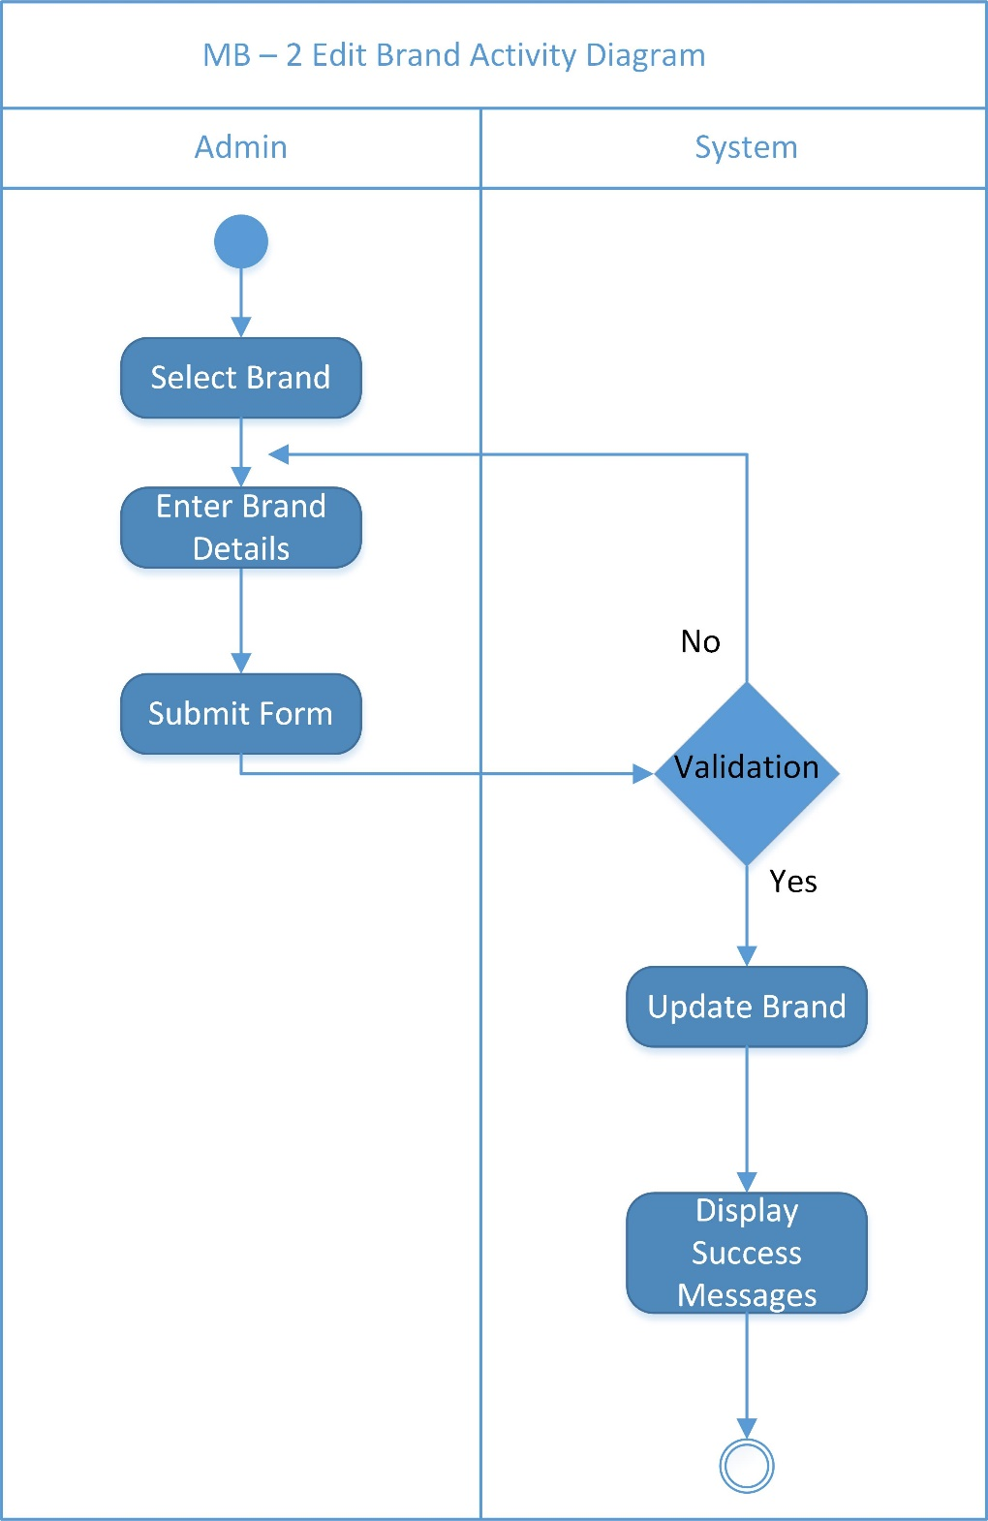

Figure Activity Diagram of Edit Brand

#### MB – 3 Remove Brand Activity Diagram of Manage Brand

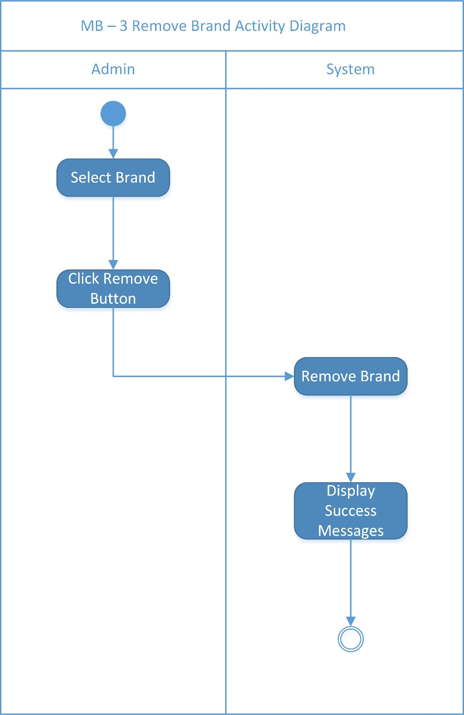

Figure Activity Diagram of Remove Brand

#### MB – 4 Display Brand Activity Diagram of Manage Brand

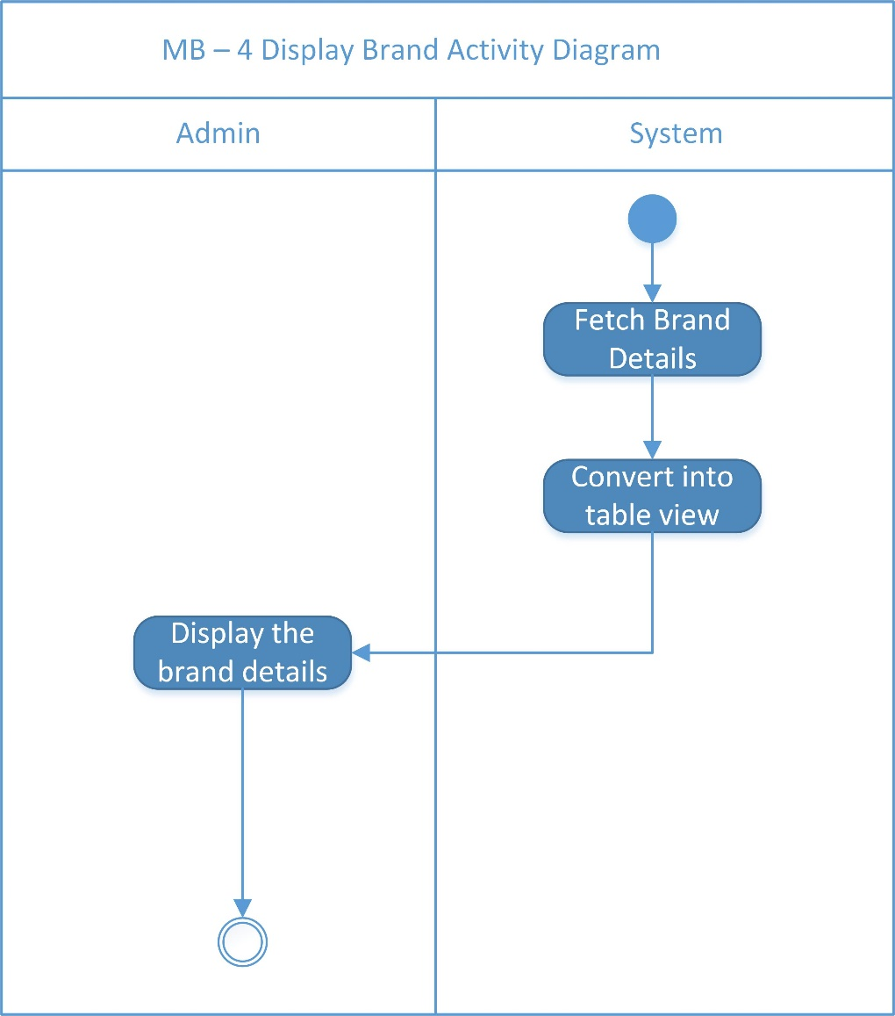

Figure Activity Diagram of Display Brand

## Manage Category [MC]

### Use Case Diagram of Manage Category

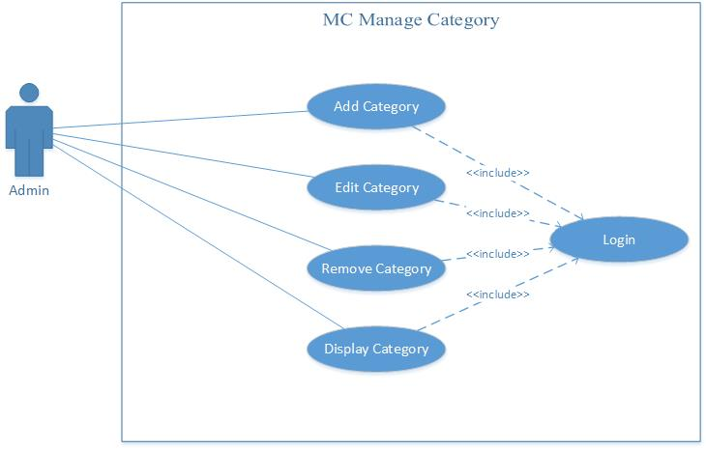

Figure Use Case Diagram of Manage Category

### Collaboration Diagram of Manage Category

#### MC – 1 Add Category Collaboration Diagram of Manage Category

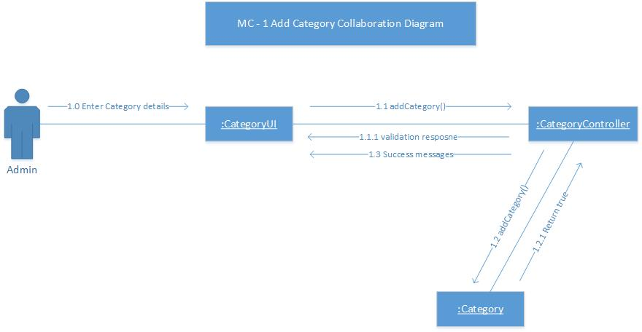

Figure Collaboration Diagram of Add Category

#### MC – 2 Edit Brand Collaboration Diagram of Manage Category

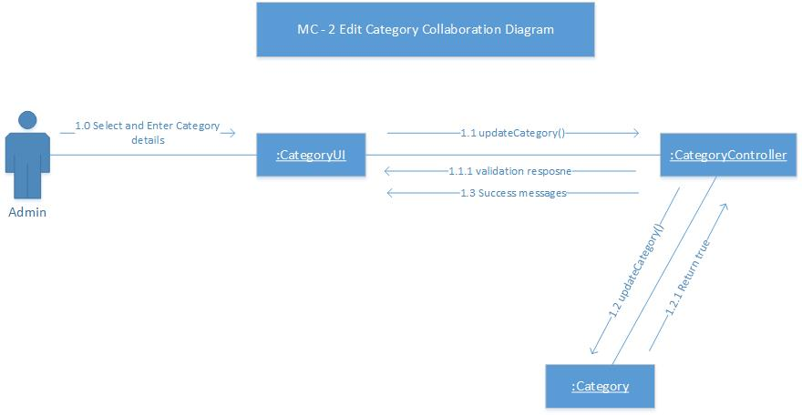

Figure Collaboration Diagram of Edit Category

#### MC – 3 Remove Brand Collaboration Diagram of Manage Category

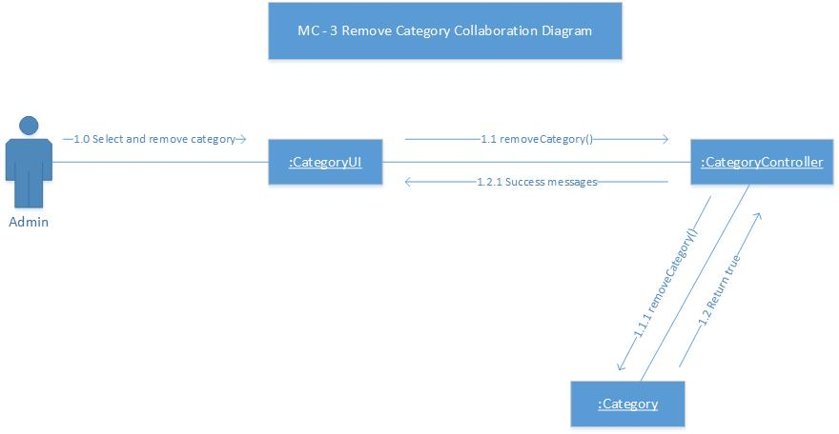

Figure Collaboration Diagram of Remove Brand

#### MC – 4 Display Brand Collaboration Diagram of Manage Category

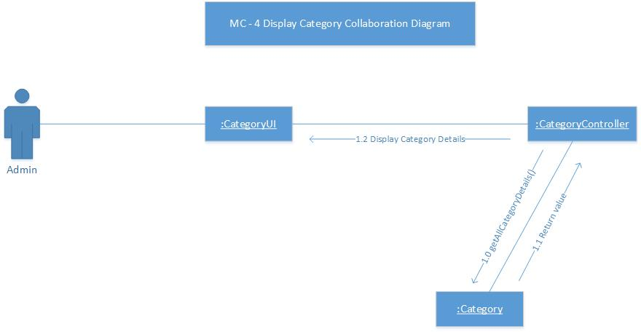

Figure Collaboration Diagram of Display Brand

### Sequence Diagram of Manage Category

#### MC – 1 Add Category Sequence Diagram of Manage Category

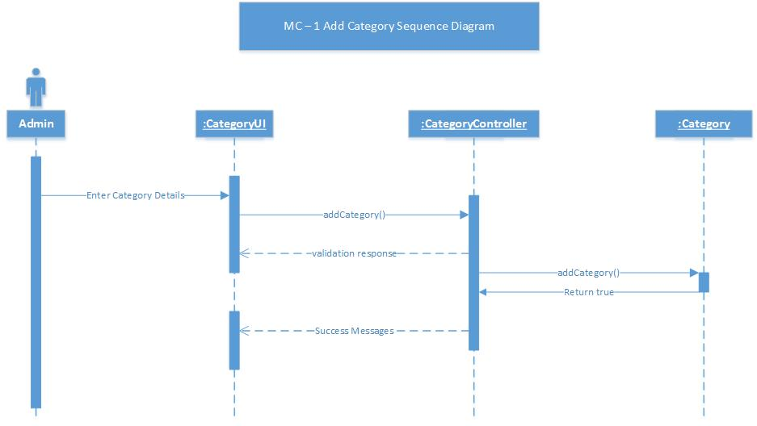

Figure Sequence Diagram of Add Category

#### MC – 2 Edit Category Sequence Diagram of Manage Category

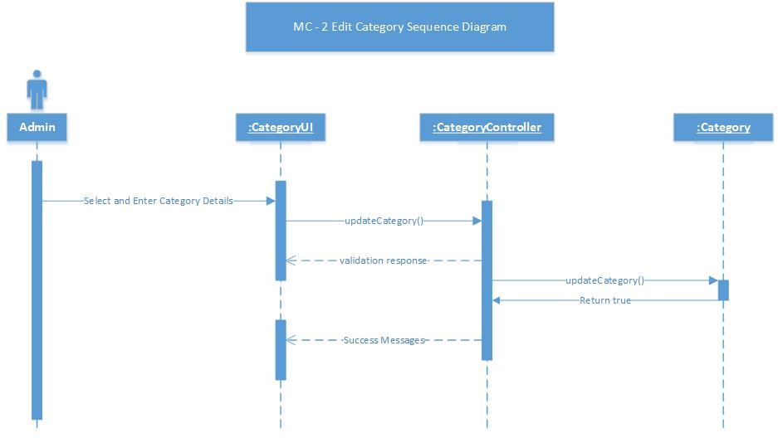

Figure Sequence Diagram of Edit Category

#### MC – 3 Remove Category Sequence Diagram of Manage Category

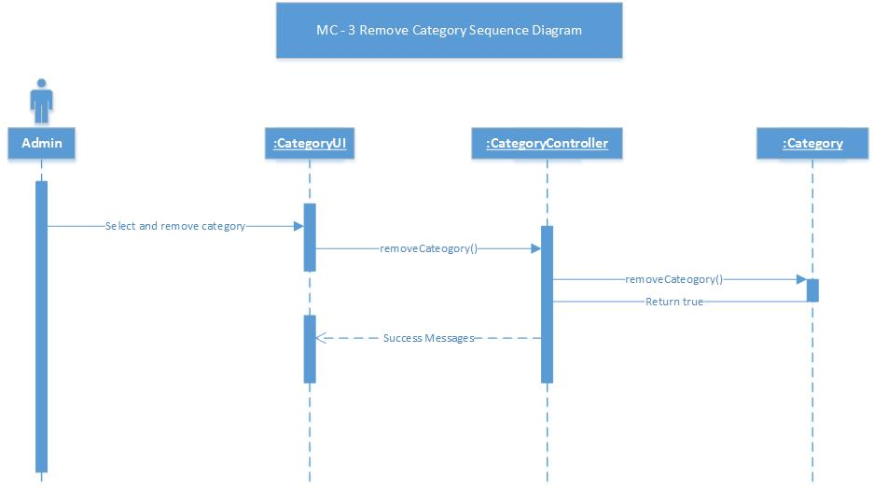

Figure Sequence Diagram of Remove Category

#### MC – 4 Display Category Sequence Diagram of Manage Category

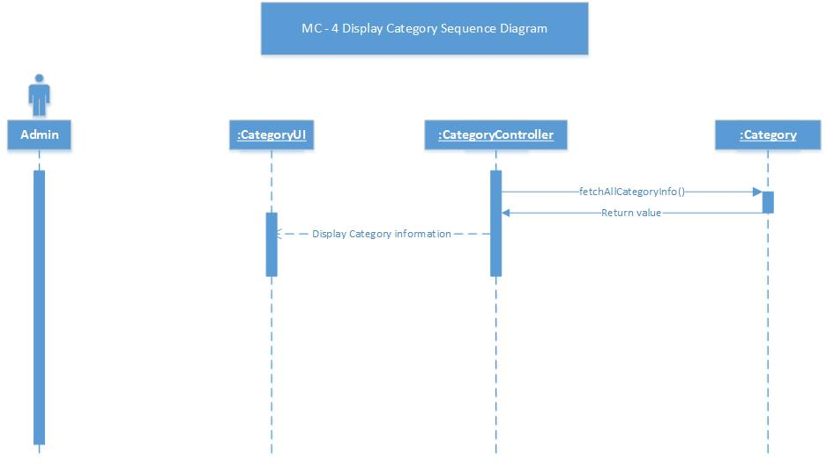

Figure Sequence Diagram of Display Category

### Activity Diagram of Manage Category

#### MC – 1 Add Category Activity Diagram of Manage Category

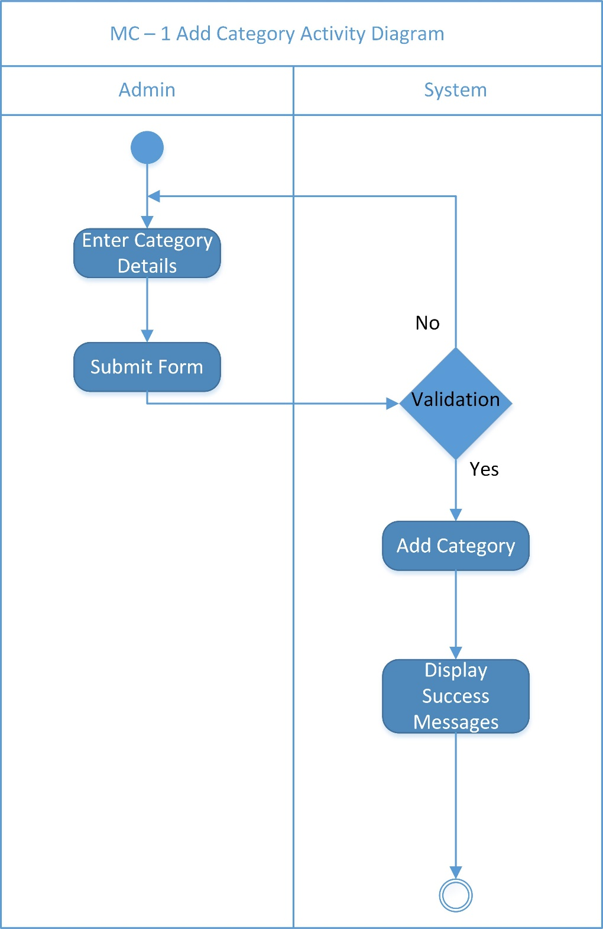

Figure Activity Diagram of Add Category

#### MC – 2 Edit Category Activity Diagram of Manage Category

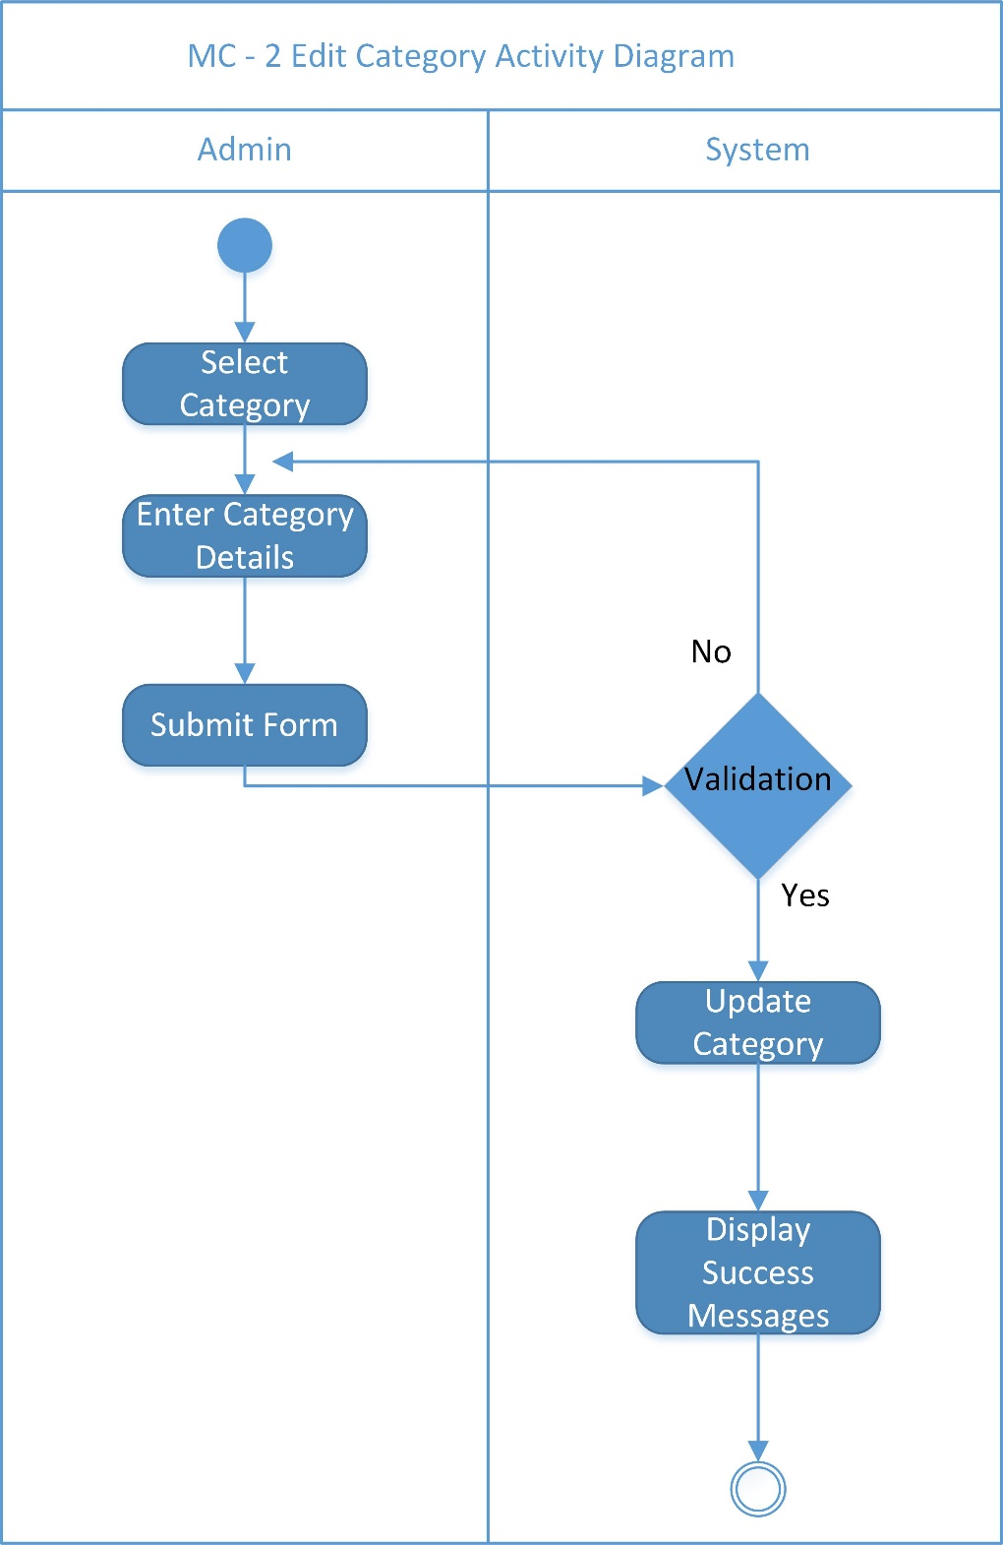

Figure Activity Diagram of Edit Categoryss

#### MC – 3 Remove Category Activity Diagram of Manage Category

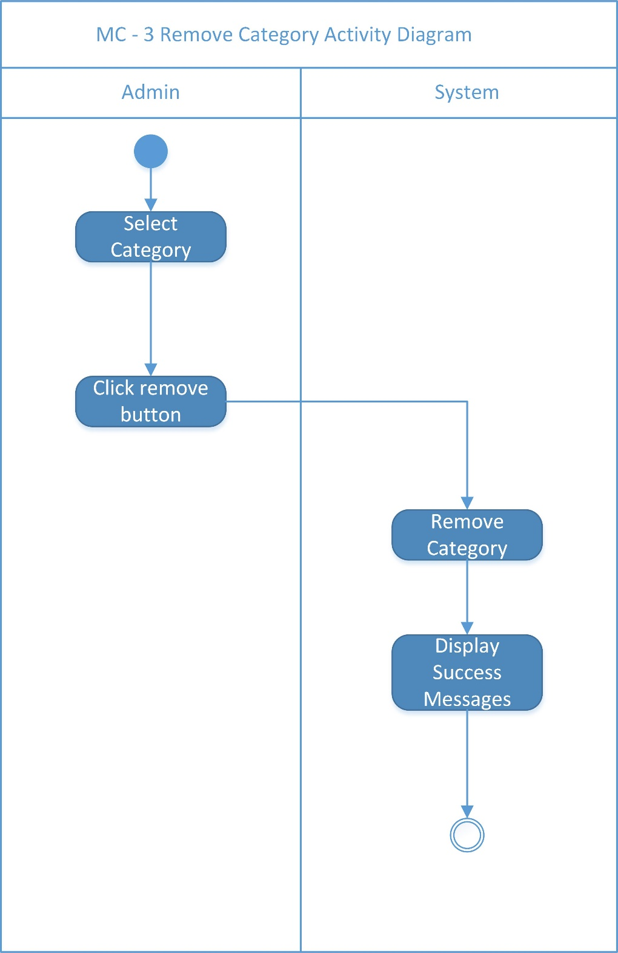

Figure Activity Diagram of Remove Category

#### MC – 4 Display Category Activity Diagram of Manage Category

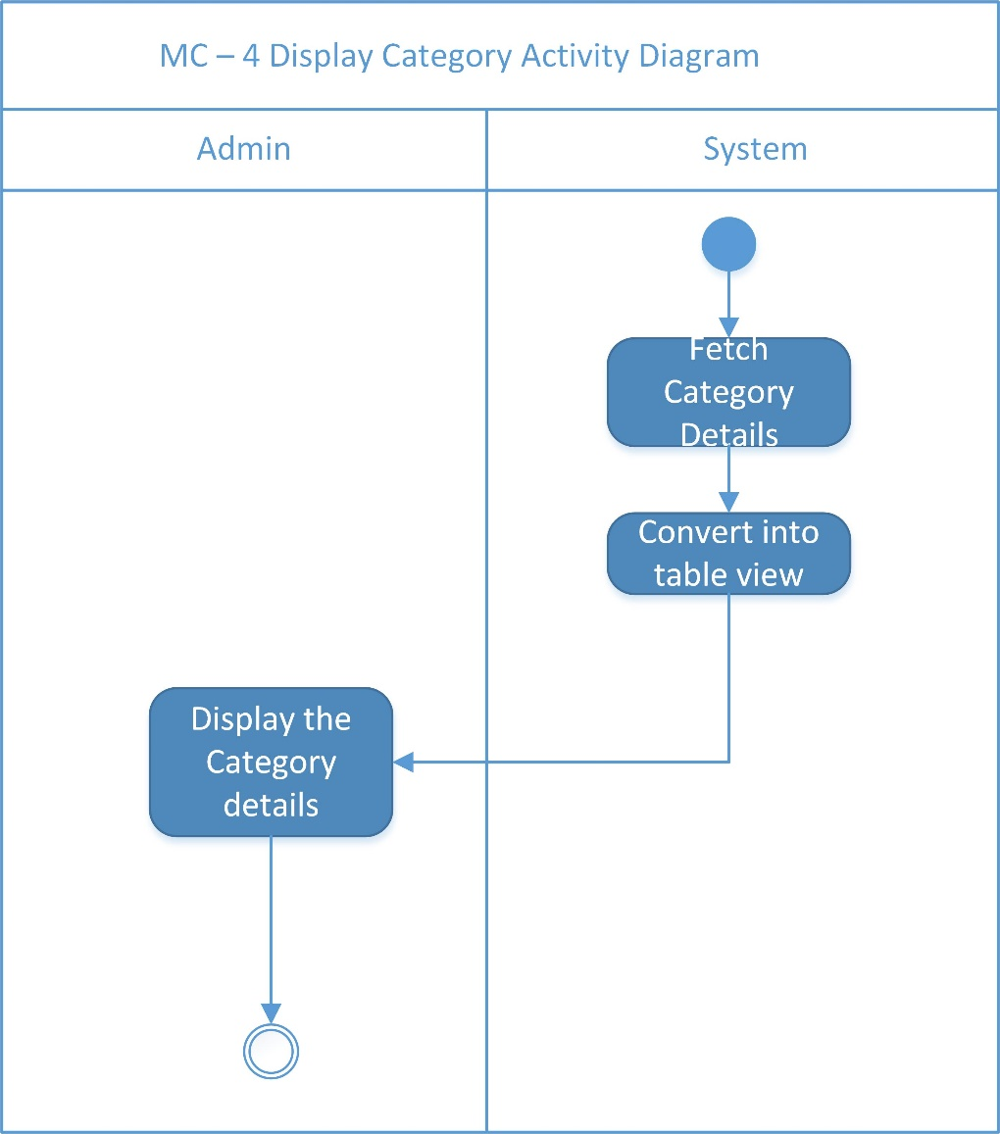

Figure Activity Diagram of Display Category

## Manage Product [MP]

### Use Case Diagram of Manage Product

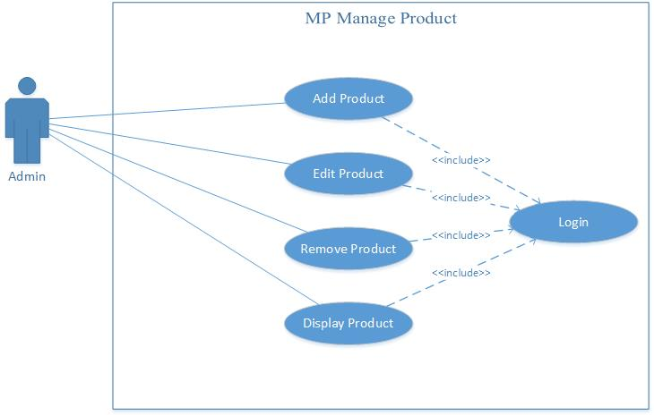

Figure Use Case Diagram of Manage Product

### Collaboration Diagram of Manage Product

#### MP – 1 Add Product Collaboration Diagram of Manage Product

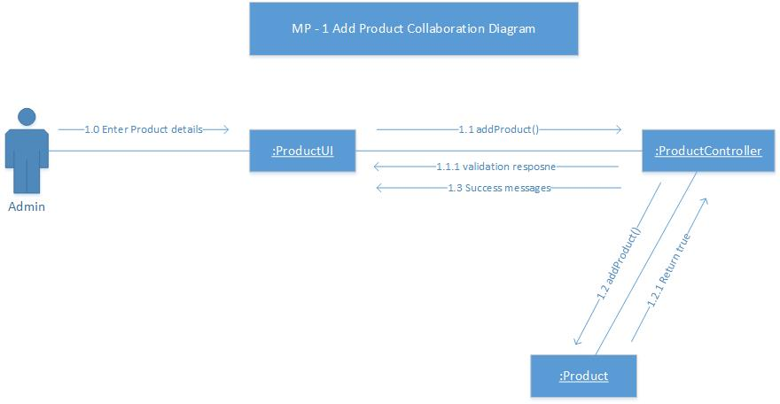

Figure Collaboration Diagram of Add Product

#### MP – 2 Edit Product Collaboration Diagram of Manage Product

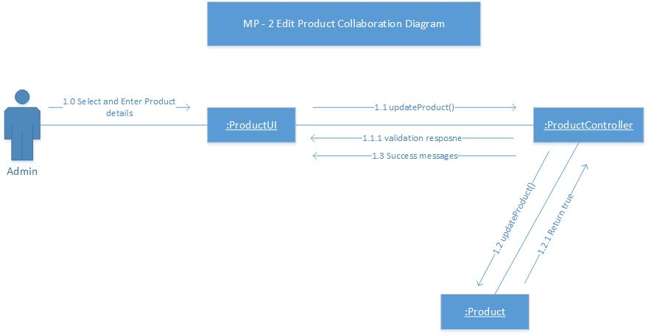

Figure Collaboration Diagram of Edit Product

#### MP – 3 Remove Product Collaboration Diagram of Manage Product

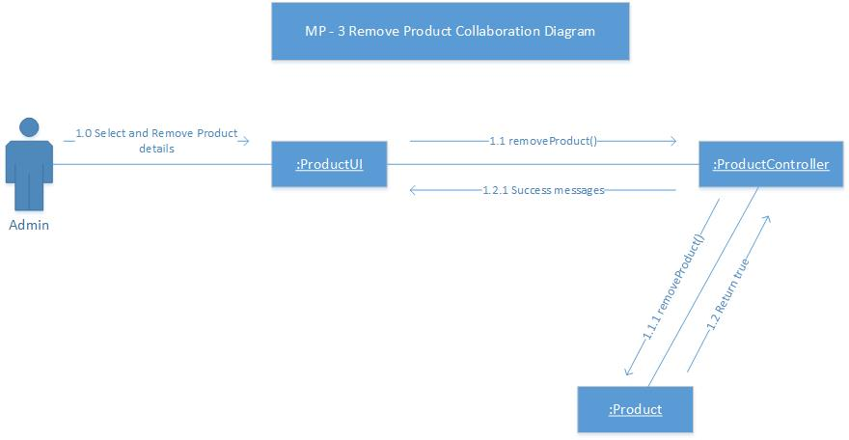

Figure Collaboration Diagram of Remove Product

#### MP – 4 Display Product Collaboration Diagram of Manage Product

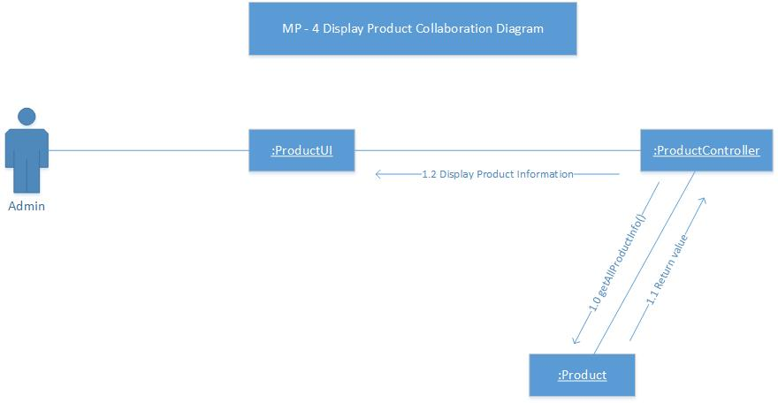

Figure Collaboration Diagram of Display Product

### Sequence Diagram of Manage Product

#### MP – 1 Add Product Sequence Diagram of Manage Product

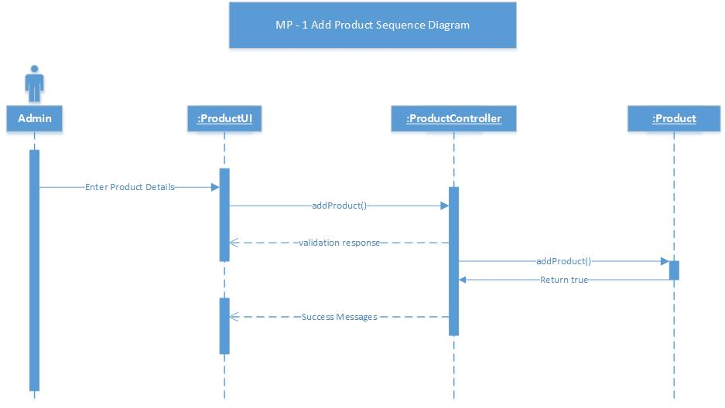

Figure Sequence Diagram of Add Product

#### MP – 2 Edit Product Sequence Diagram of Manage Product

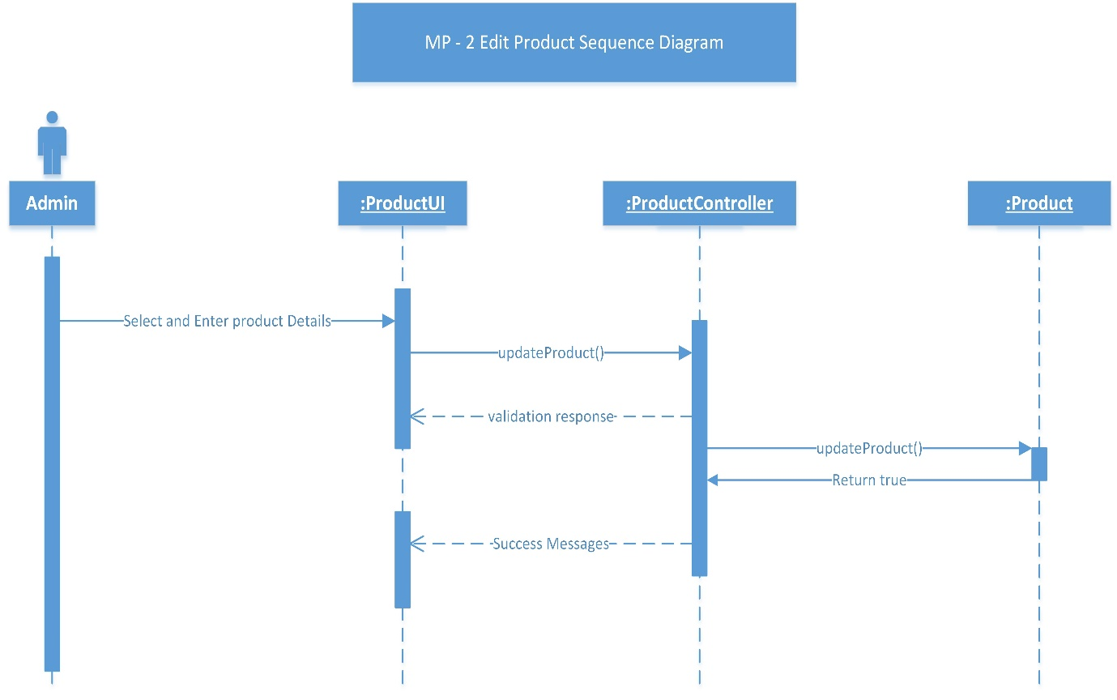

Figure Sequence Diagram of Edit Product

#### MP – 3 Remove Product Sequence Diagram of Manage Product

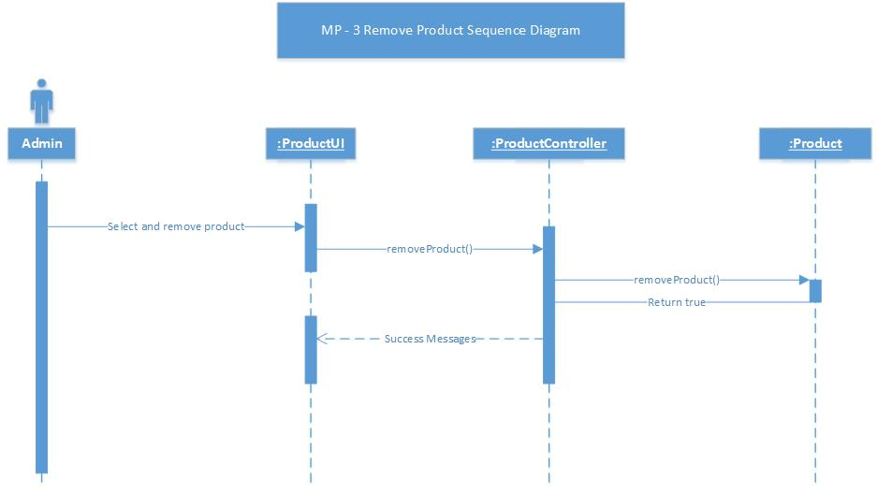

Figure Sequence Diagram of Remove Product

#### MP – 4 Display Product Sequence Diagram of Manage Product

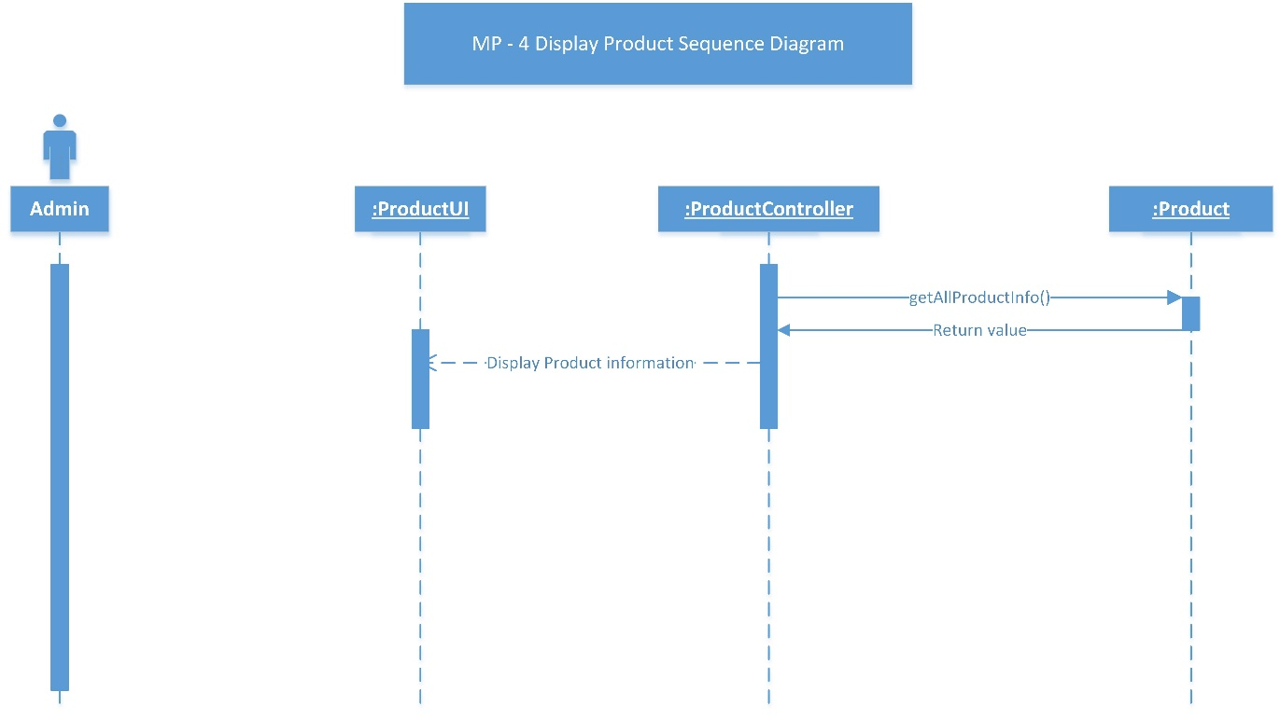

Figure Sequence Diagram of Display Product

### Activity Diagram of Manage Product

#### MP – 1 Add Product Activity Product of Manage Product

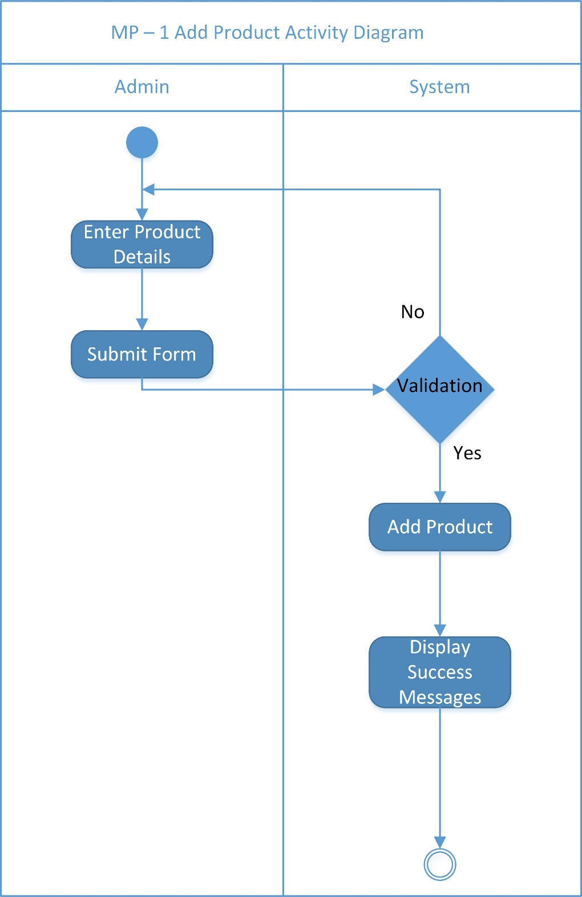

Figure Activity Diagram of Add Product

#### MP – 2 Edit Product Activity Product of Manage Product

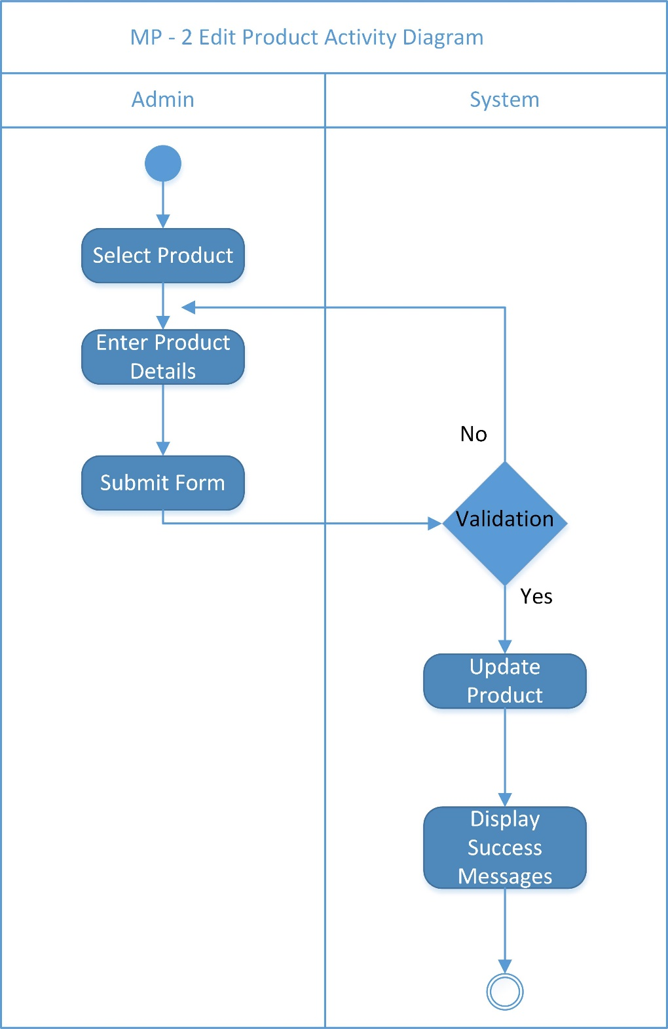

Figure Activity Diagram of Edit Product

#### MP – 3 Remove Product Activity of Manage Product

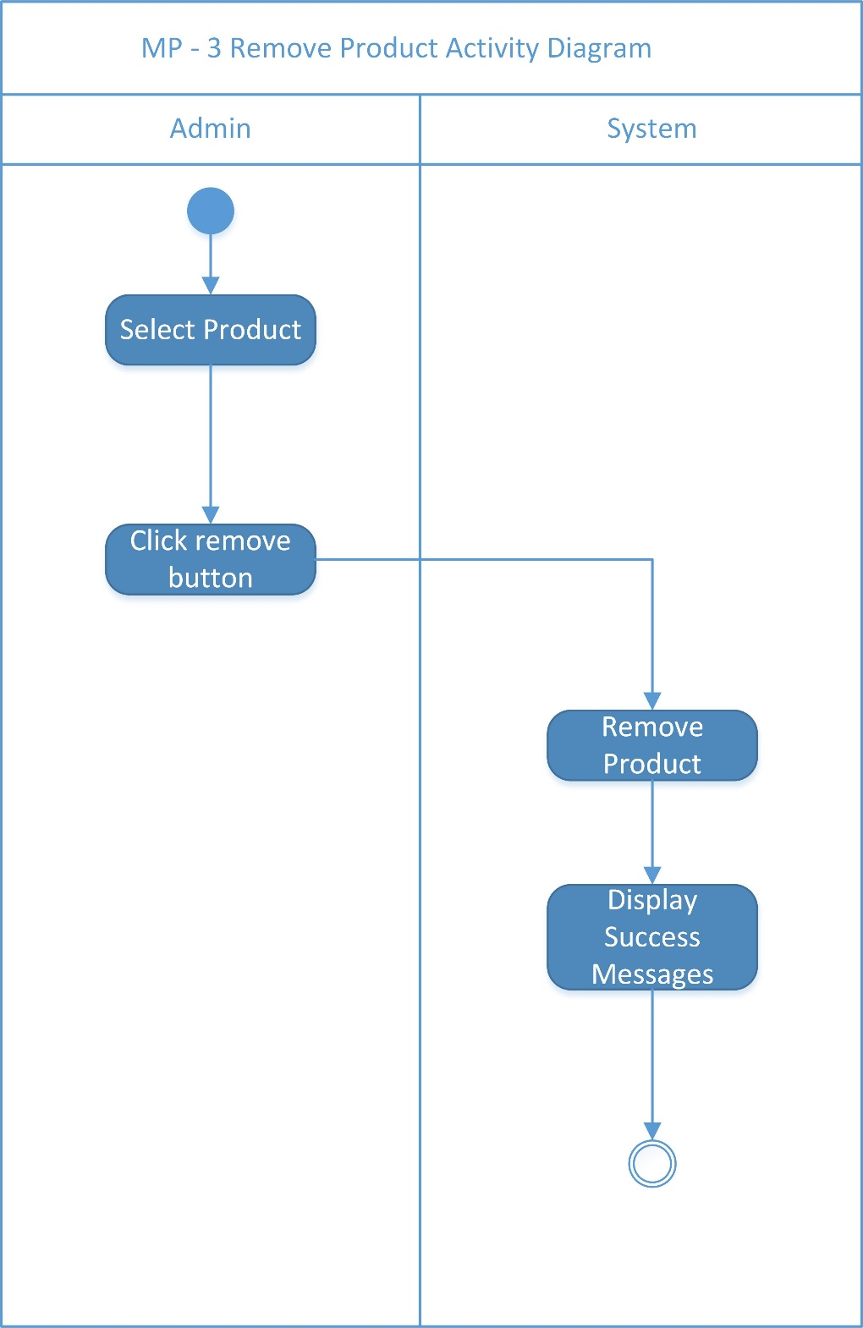

Figure Activity Diagram of Remove Product

#### MP – 4 Display Product Activity Diagram of Manage Product

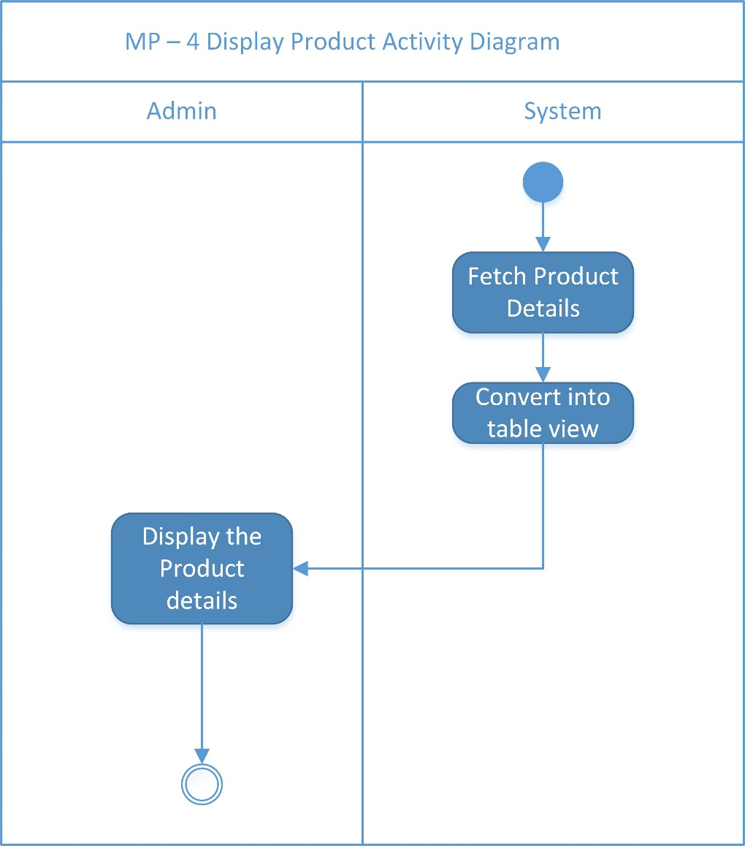

Figure Activity Diagram of Display Product

## Manage Orders [MO]

### Use Case Diagram of Manage Orders

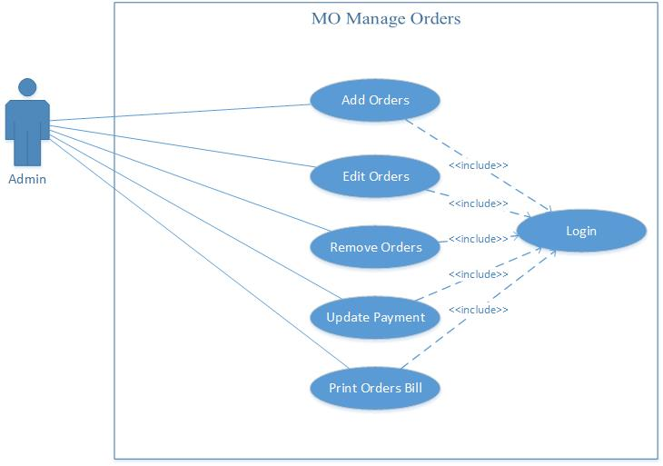

Figure Use Case Diagram of Manage Orders

### Collaboration Diagram of Manage Orders

#### MO – 1 Add Orders Collaboration Diagram of Manage Orders

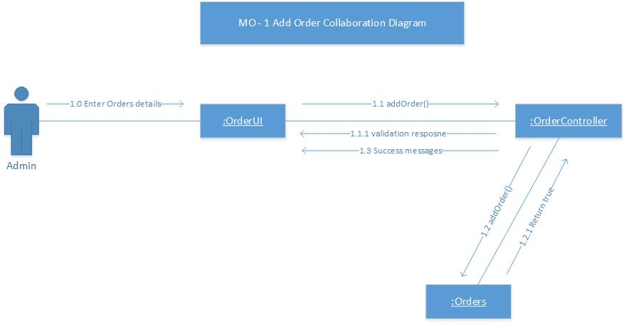

Figure Collaboration Diagram of Add Order

#### MO – 2 Edit Orders Collaboration Diagram of Manage Orders

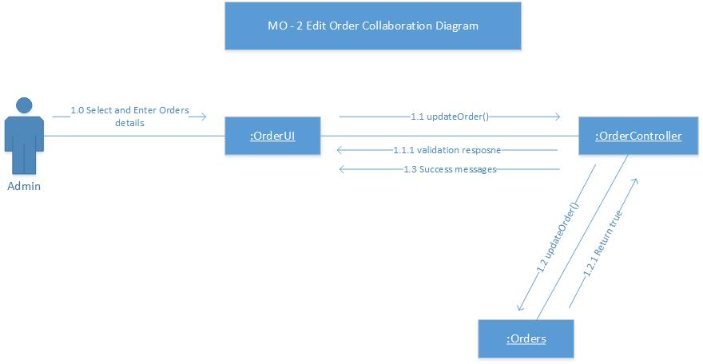

Figure Collaboration Diagram of Edit Order

#### MO – 3 Remove Orders Collaboration Diagram of Manage Orders

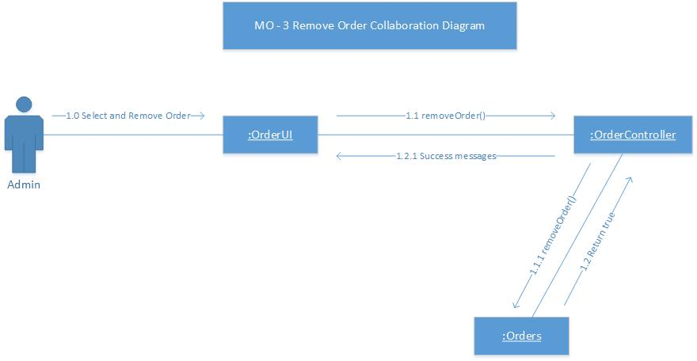

Figure Collaboration Diagram of Remove Order

#### MO – 4 Display Orders Collaboration Diagram of Manage Orders

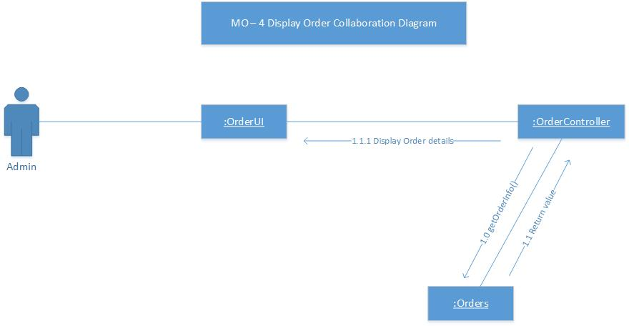

Figure Collaboration Diagram of Display Orders

#### MO – 5 Print Orders Collaboration Diagram of Manage Orders

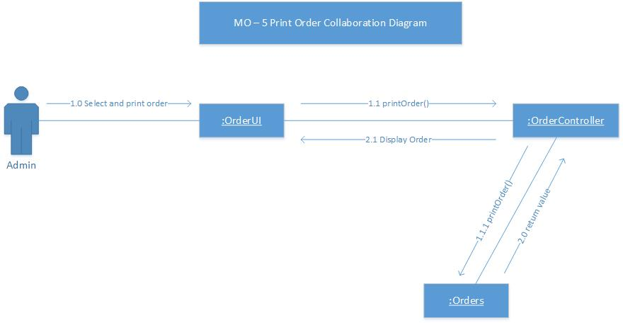

Figure Collaboration Diagram of Print Orders

### Sequence Diagram of Manage Orders

#### MO – 1 Add Orders Sequence Diagram of Manage Orders

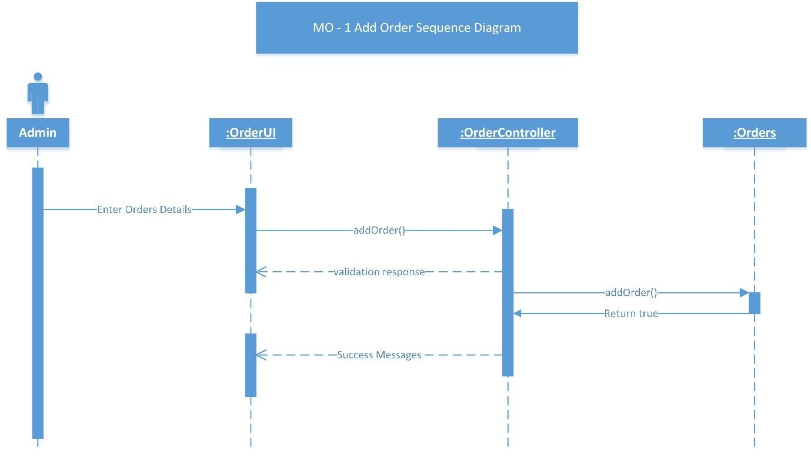

Figure Sequence Diagram of Add Orders

#### MP – 2 Edit Orders Sequence Diagram of Manage Orders

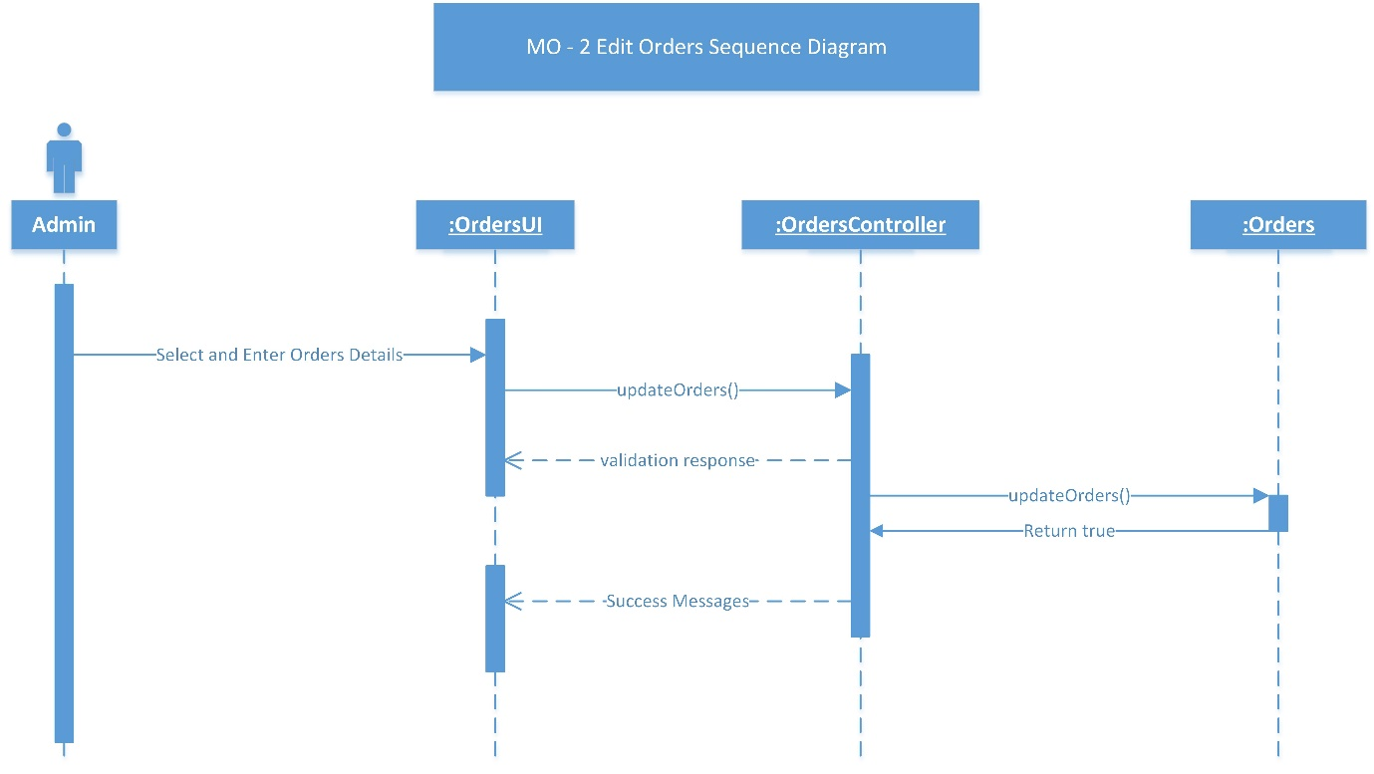

Figure Sequence Diagram of Edit Orders

#### MP – 3 Remove Orders Sequence Diagram of Manage Orders

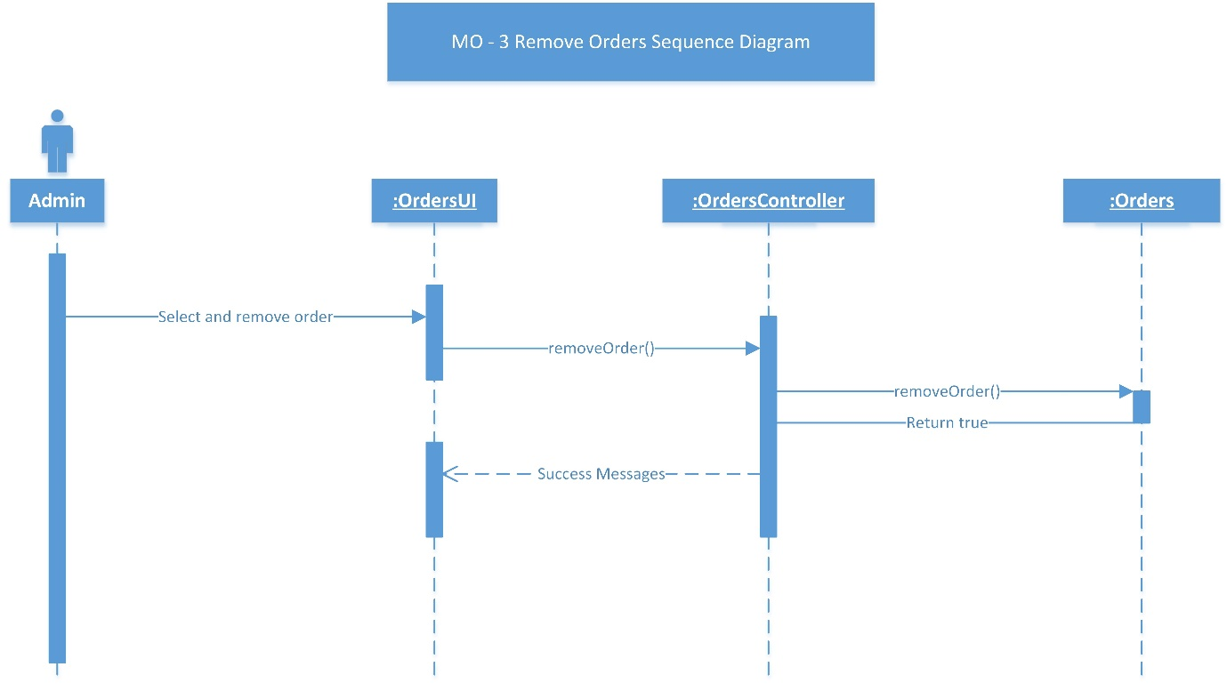

Figure Sequence Diagram of Remove Orders

#### MP – 4 Display Orders Sequence Diagram of Manage Orders

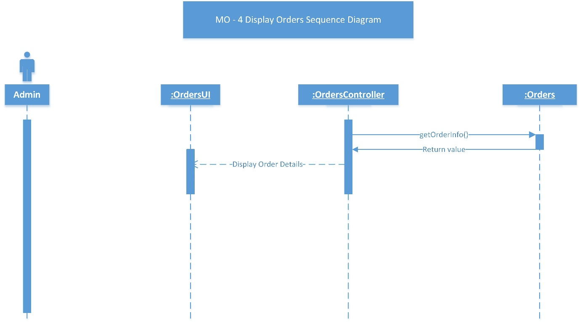

Figure Sequence Diagram of Display Orders

#### MP – 5 Print Orders Sequence Diagram of Manage Orders

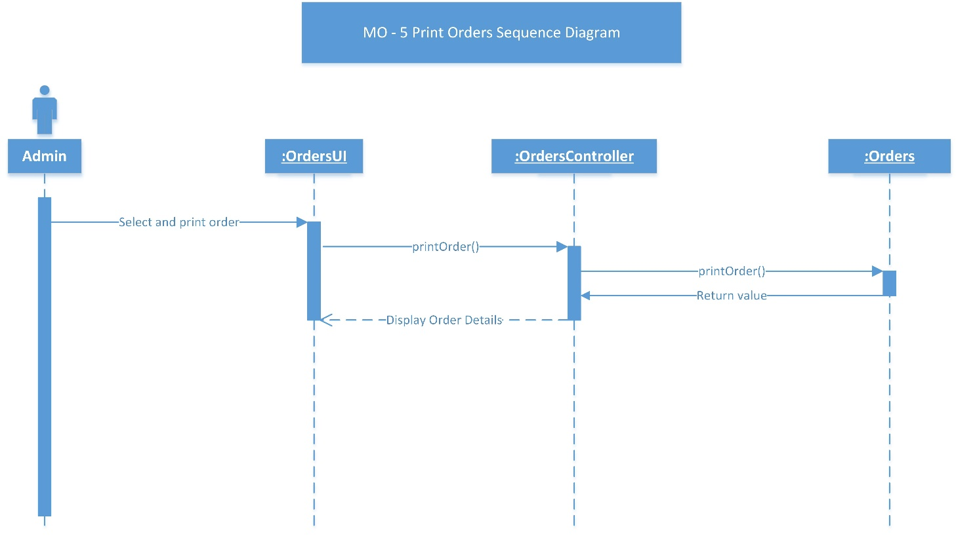

Figure Sequence Diagram of Print Orders

### Activity Diagram of Manage Orders

#### MO – 1 Add Orders Activity Diagram of Manage Orders

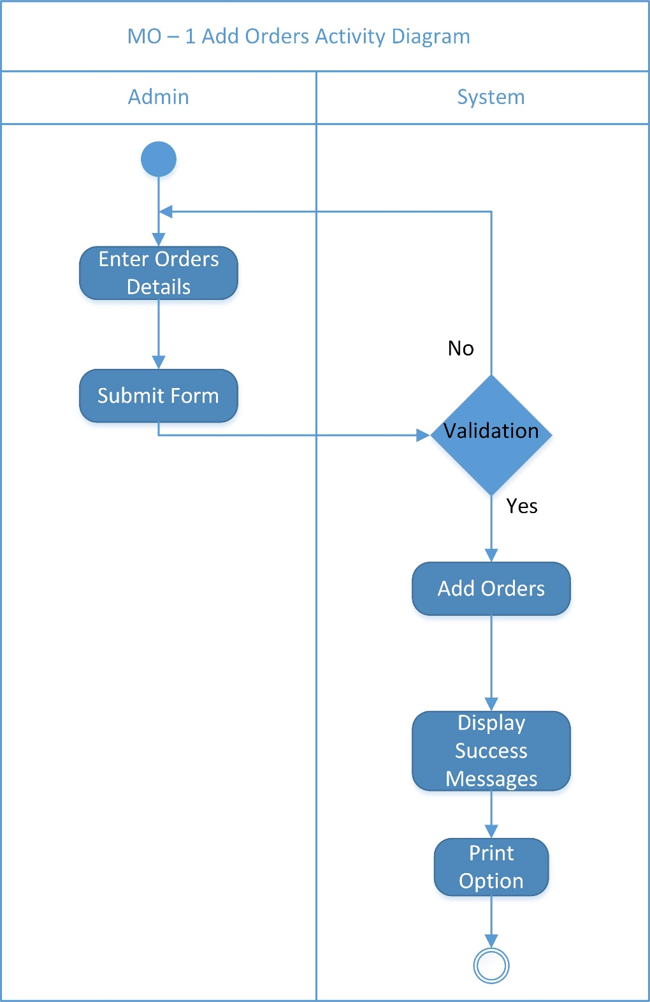Figure Activity Diagram of Add Orders

#### MO – 2 Edit Orders Activity Diagram of Manage Orders

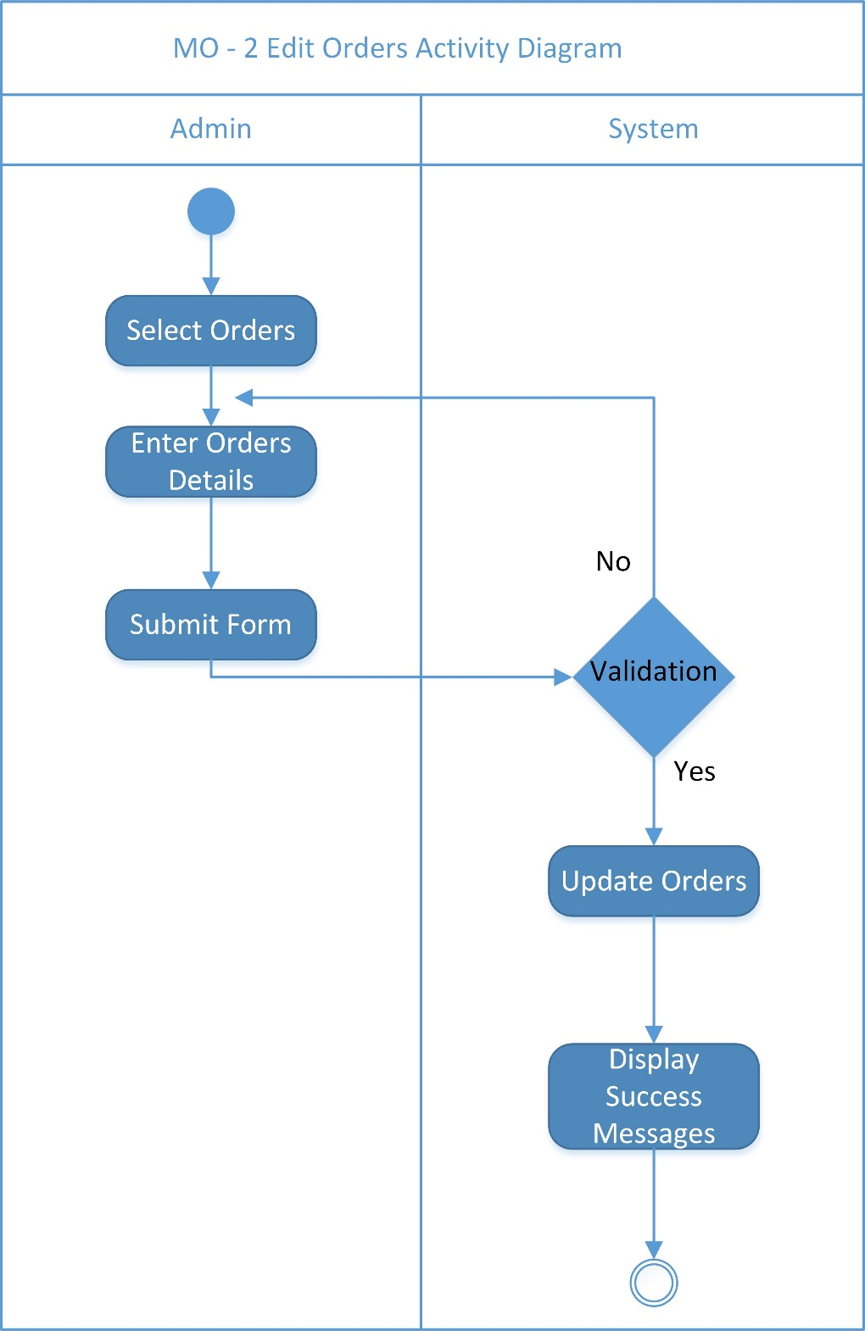

Figure Activity Diagram of Edit Orders

#### MO – 3 Remove Orders Activity Diagram of Manage Orders

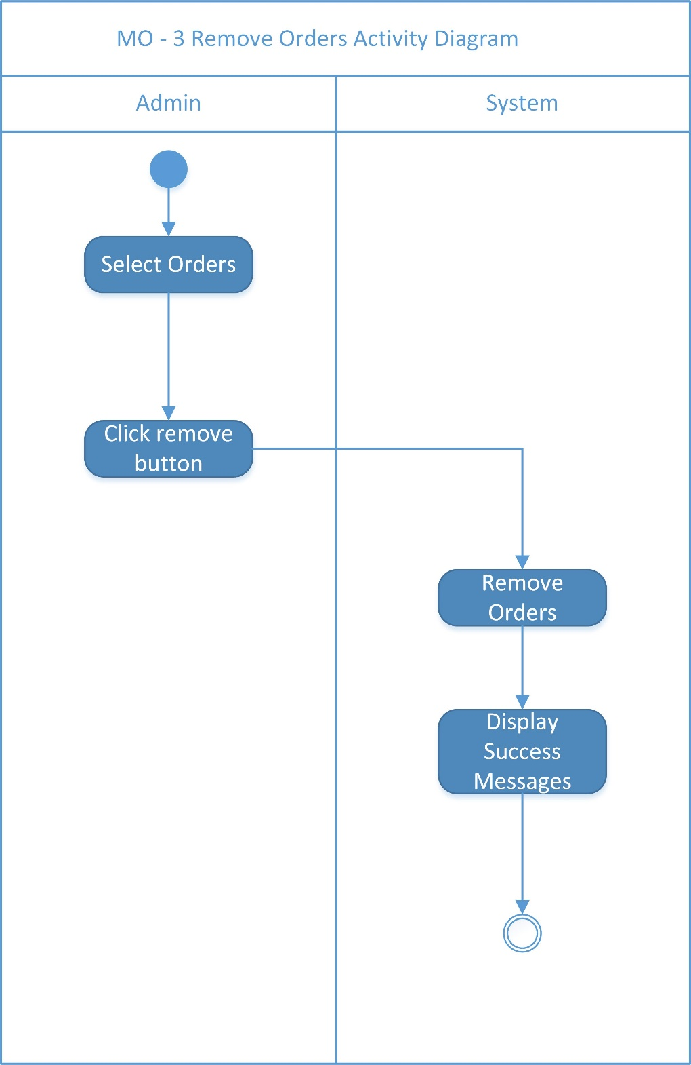

Figure Activity Diagram of Remove Orders

#### MO – 4 Display Orders Activity Diagram of Manage Orders

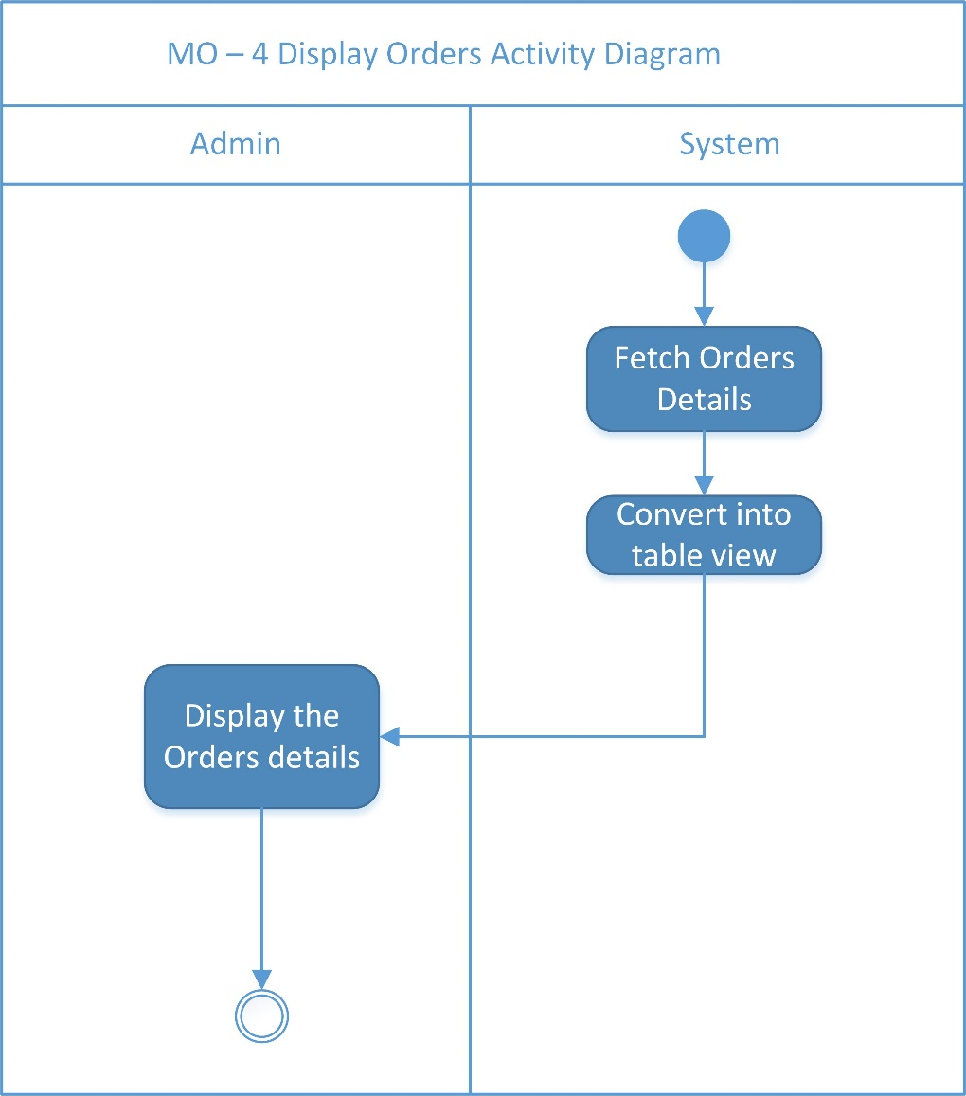

Figure Activity Diagram of Display Orders

#### MO – 5 Print Orders Bill Activity Diagram of Manage Orders

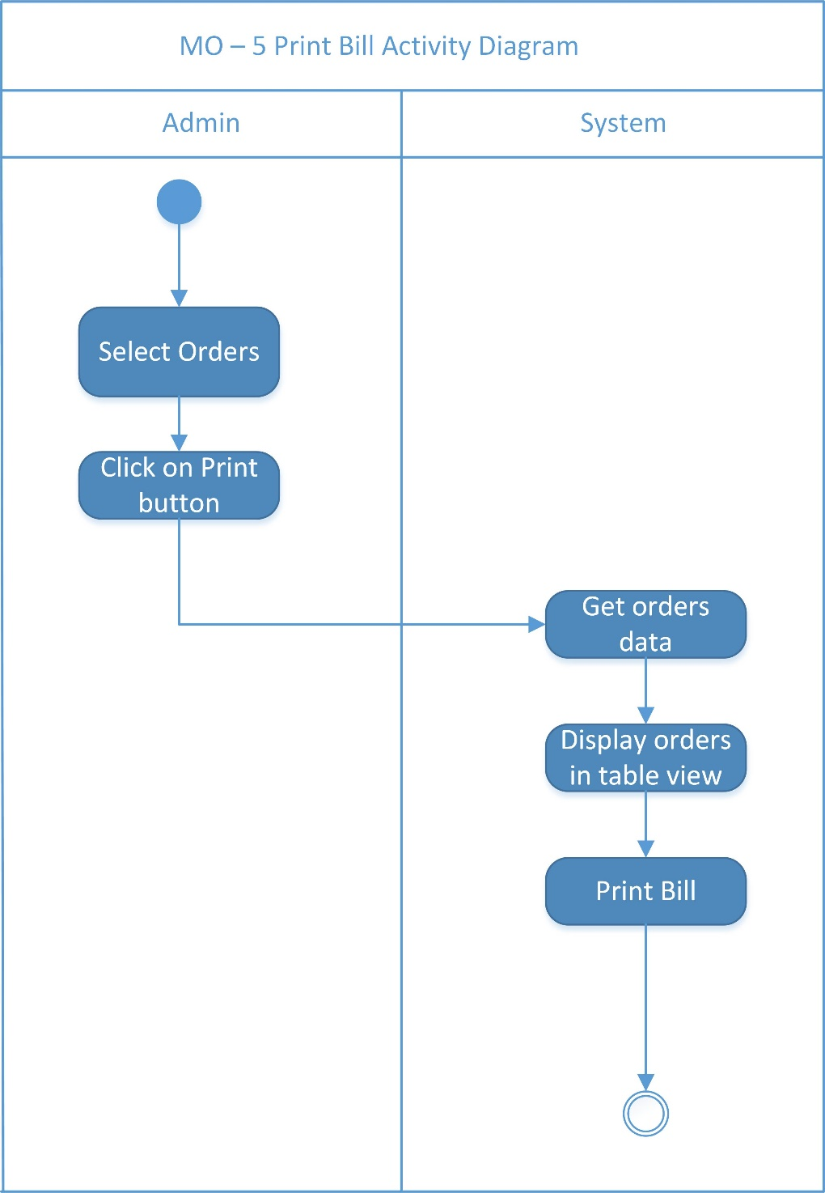

Figure Activity Diagram of Print Orders Bill

## Generate Orders Report [GOR]

### Use Case Diagram of Generate Orders Report

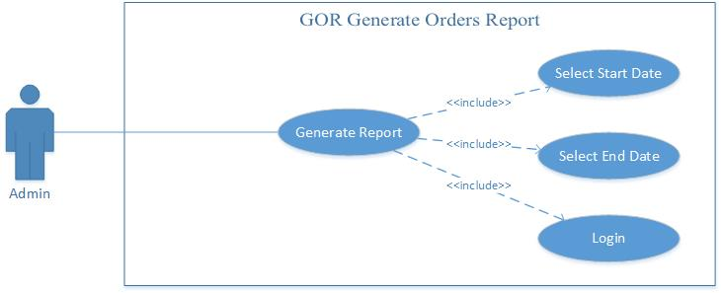

Figure Use Case Diagram of Generate Orders Report

### Collaboration Diagram of Generate Orders Report

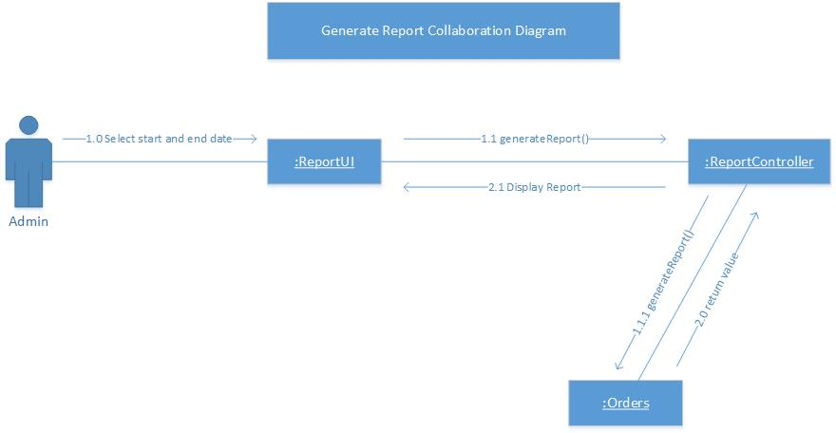

Figure Collaboration Diagram of Generate Report

### Sequence Diagram of Generate Orders Report

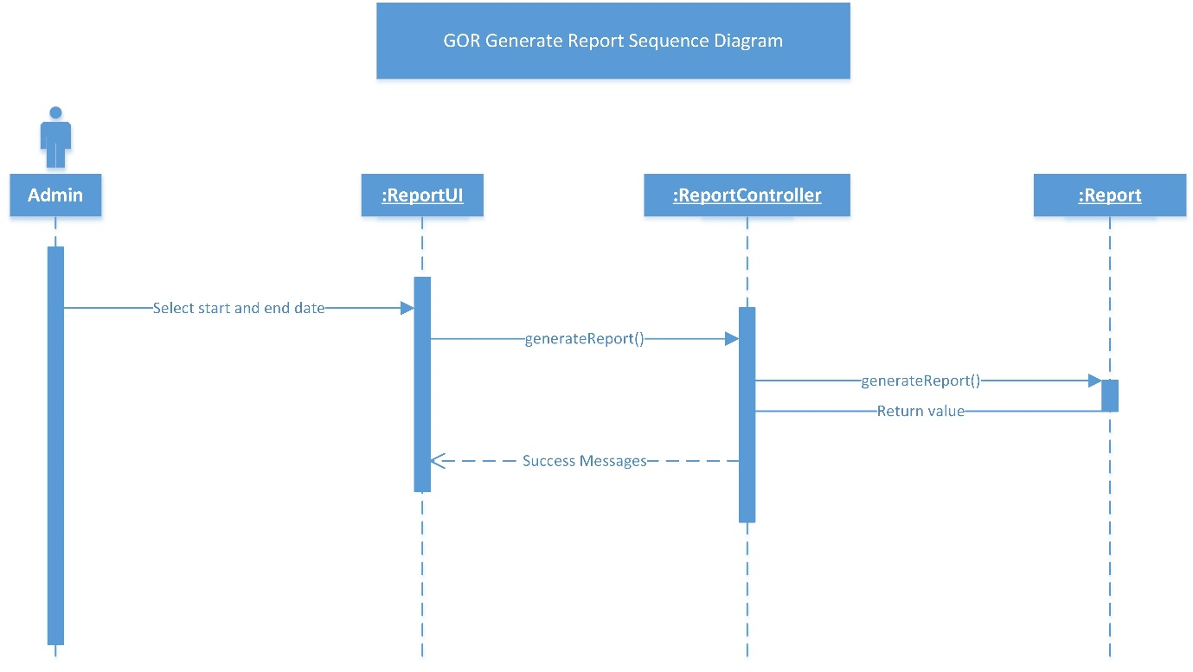

Figure Sequence Diagram of Generate Orders Report

### Activity Diagram of Generate Orders Report

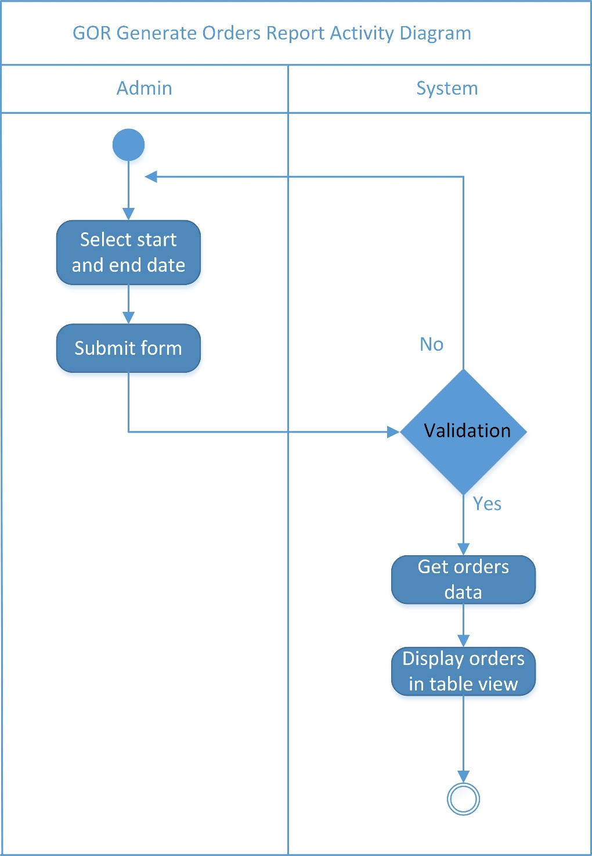

Figure Activity Diagram of Generate Orders Reports

## Entity Relationship Diagram

### List of Entities

There are 6 entities used in this system. All entities are listed below:

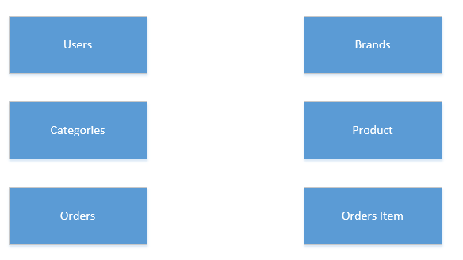

Figure List of Entities

### Relationship with Entities

The figures below shows the relationship between the entities:

#### Product – Brands

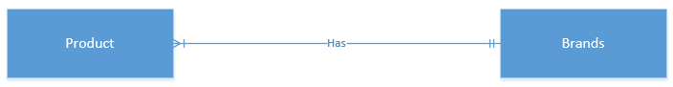

Figure Product - Brands Entity Relationship

* Product have one brands
* One Brands have Multiple Product

#### Product – Category

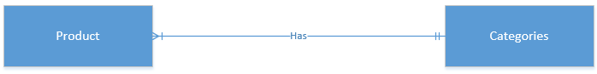

Figure Product – Category Entity Relationship

* Product have one category
* One category have multiple product

#### Orders Item – Product

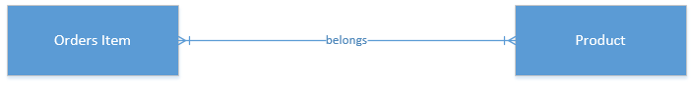

Figure Orders Item – Product Entity Relationship

* An Orders Item have multiple products.
* One product have multiple Orders Item.

#### Orders Item – Orders

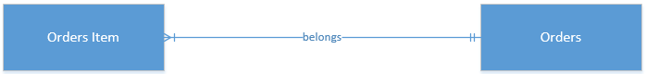

Figure Orders Item - Orders Entity Relationship

* An Orders Item have one orders.
* An orders have multiple orders item.

### ER – Diagram

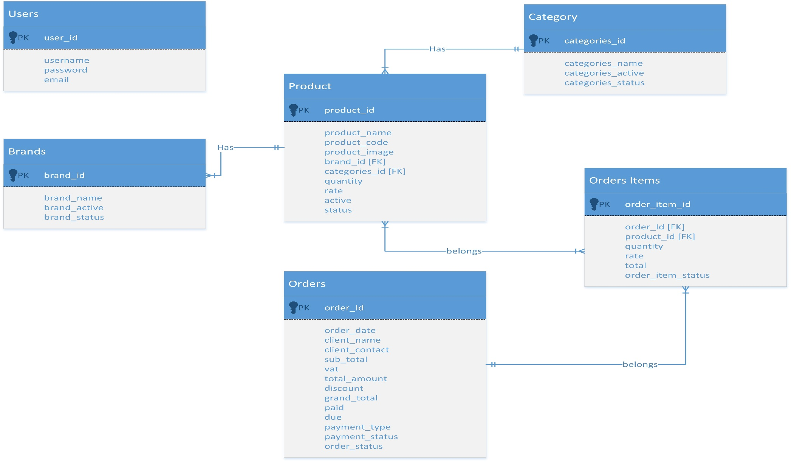

Figure Entity Relationship Diagram ERD

### Data Dictionary

A data dictionary is a collection of descriptions of the data objects or items in a data model for the benefit of programmers and others who need to refer to them. A first step in analyzing a system of objects with which users interact is to identify each object and its relationship to other objects. This process is called data modeling and results in a picture of object relationships. (TechTarget, 2005)

#### Table: Users

|  |  |  |  |  |  |
| --- | --- | --- | --- | --- | --- |
| **Column** | **Type** | **Null** | **Default** | **Comments** | **MIME** |
| user_id | INT(11) | No |  |  |  |
| username | VARCHAR(255) | No |  |  |  |
| password | VARCHAR(255) | No |  |  |  |
| email | VARCHAR(255) | No |  |  |  |

Table Table: Users

#### Table: Brand

|  |  |  |  |  |  |
| --- | --- | --- | --- | --- | --- |
| **Column** | **Type** | **Null** | **Default** | **Comments** | **MIME** |
| brand_id | INT(11) | No |  |  |  |
| brand_name | VARCHAR(255) | No |  |  |  |
| brand_active | INT(11) | No | 0 |  |  |
| brand_status | INT(11) | No | 0 |  |  |

Table Table: Brand

#### Table: Category

|  |  |  |  |  |  |
| --- | --- | --- | --- | --- | --- |
| **Column** | **Type** | **Null** | **Default** | **Comments** | **MIME** |
| categories_id | INT(11) | No |  |  |  |
| categories_name | VARCHAR(255) | No |  |  |  |
| categories_active | INT(11) | No | 0 |  |  |
| categories_status | INT(11) | No | 0 |  |  |

Table Table: Category

#### Table: Product

|  |  |  |  |  |  |
| --- | --- | --- | --- | --- | --- |
| **Column** | **Type** | **Null** | **Default** | **Comments** | **MIME** |
| product_Id | INT(11) | No |  |  |  |
| product_name | VARCHAR(255) | No |  |  |  |
| product_image | VARCHAR(255) | No |  |  |  |
| brand_id | INT(11) | No |  |  |  |
| categories_id | INT(11) | NO |  |  |  |
| quantity | VARCHAR(255) | NO |  |  |  |
| rate | VARCHAR(255) | No |  |  |  |
| active | INT(11) | No | 0 |  |  |
| status | INT(11) | No | 0 |  |  |

Table Table: Product

#### Table: Orders

|  |  |  |  |  |  |
| --- | --- | --- | --- | --- | --- |
| **Column** | **Type** | **Null** | **Default** | **Comments** | **MIME** |
| order_id | INT(11) | No |  |  |  |
| order_date | DATE | No |  |  |  |
| client_name | VARCHAR(255) | No |  |  |  |
| client_contact | VARCHAR(255) | No |  |  |  |
| sub_total | VARCHAR(255) | No |  |  |  |
| vat | VARCHAR(255) | No |  |  |  |
| total_amount | VARCHAR(255) | No |  |  |  |
| discount | VARCHAR(255) | No |  |  |  |
| grand_total | VARCHAR(255) | No |  |  |  |
| paid | VARCHAR(255) | No |  |  |  |
| due | VARCHAR(255) | No |  |  |  |
| payment_type | INT(11) | No |  |  |  |
| payment_status | INT(11) | No |  |  |  |
| order_status | INT(11) | No | 0 |  |  |

Table Table: Orders

#### Table: Orders Item

|  |  |  |  |  |  |
| --- | --- | --- | --- | --- | --- |
| **Column** | **Type** | **Null** | **Default** | **Comments** | **MIME** |
| order_item_id | INT(11) | No |  |  |  |
| order_id | INT(11) | No | 0 |  |  |
| product_id | INT(11) | No | 0 |  |  |
| quantity | VARCHAR(255) | No |  |  |  |
| rate | VARCHAR(255) | No |  |  |  |
| total | VARCHAR(255) | No |  |  |  |
| order_item_status | INT(11) | No | 0 |  |  |

Table Table: Orders Item

## Wireframe Design

### Login

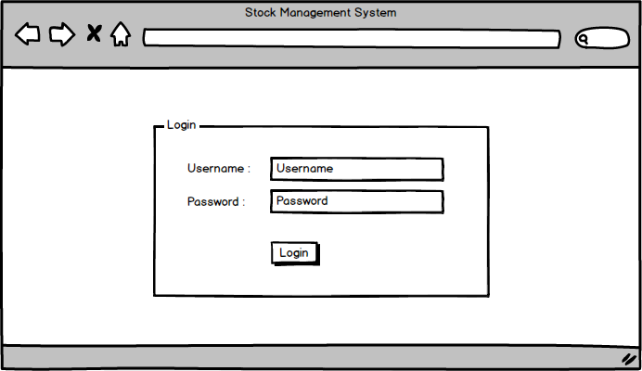

Figure Wireframe Design of Login

### Dashboard

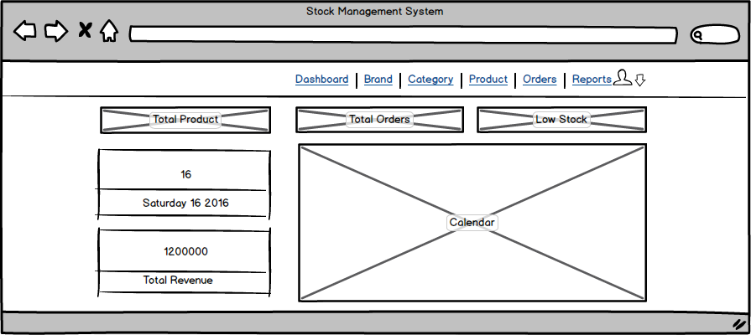

Figure Wireframe Design of Dashboard

### Manage Brands

#### Add Brands

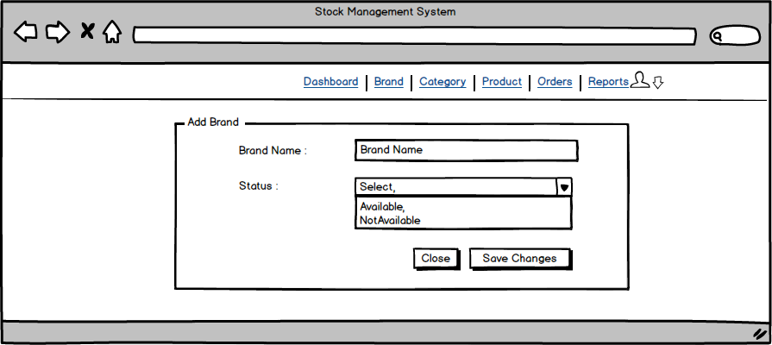

Figure Wireframe Design for Add Brands

#### Edit Brands

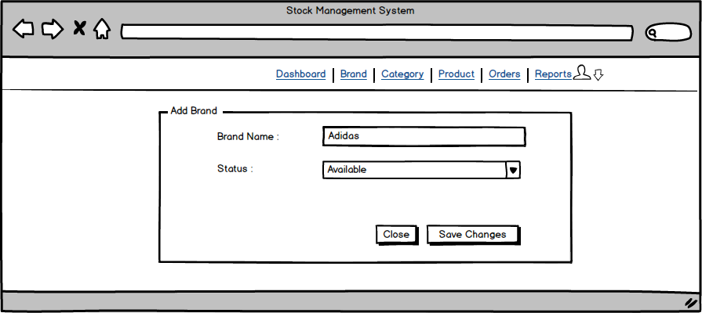

Figure Wireframe Design for Edit Brands

#### Remove Brands

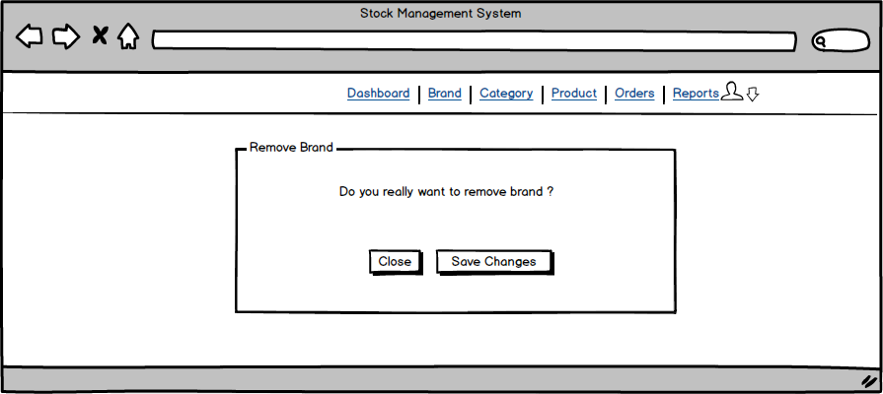

Figure Wireframe Design for Remove Brand

#### Display Brands

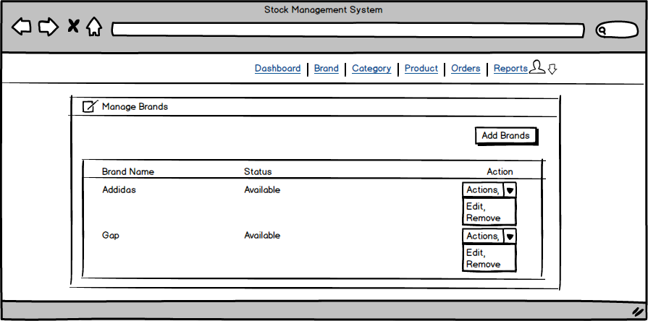

Figure Wireframe Design for Display Brands

### Manage Category

#### Add Category

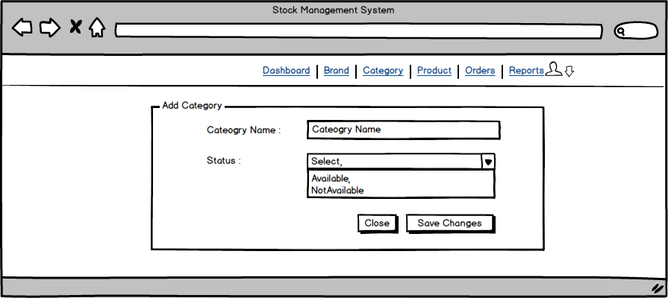

Figure Wireframe Design for Add Category

#### Edit Category

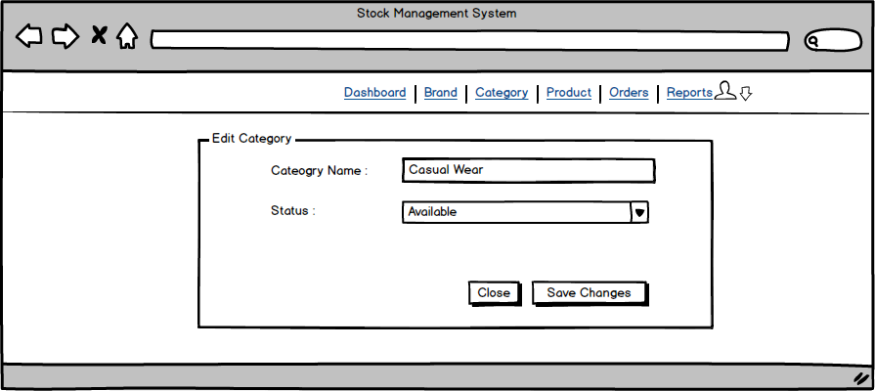

Figure Wireframe Design for Edit Category

#### Remove Category

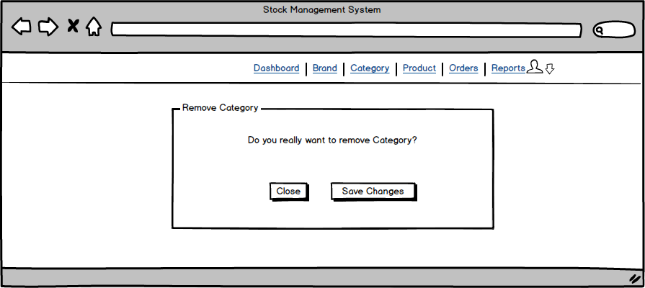

Figure Wireframe Design for Remove Category

#### Display Category

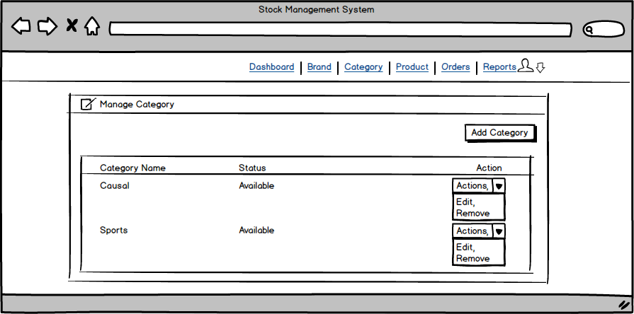

Figure Wireframe Design for Display Category

### Manage Product

#### Add Product

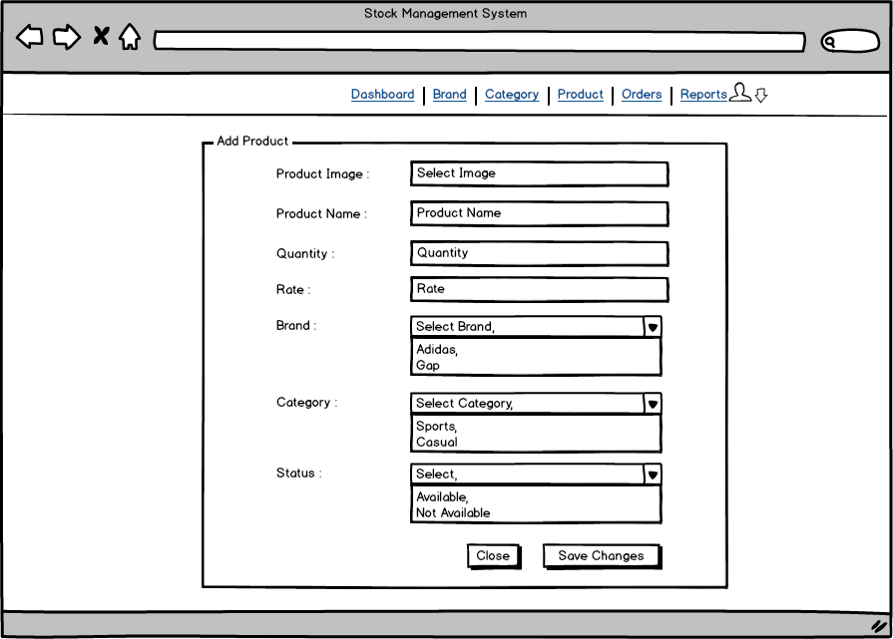

Figure Wireframe Design for Add Product

#### Edit Product

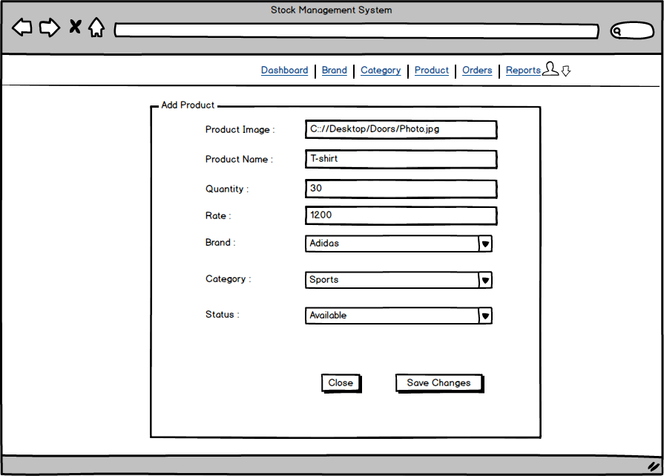

Figure Wireframe Design for Edit Product

#### Remove Product

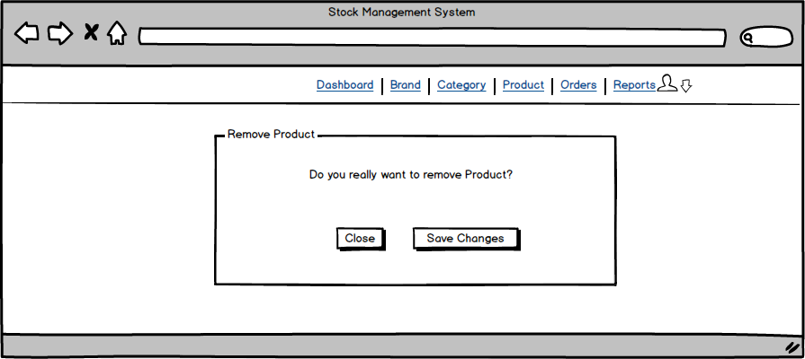

Figure Wireframe Design for Remove Product

#### Display Product

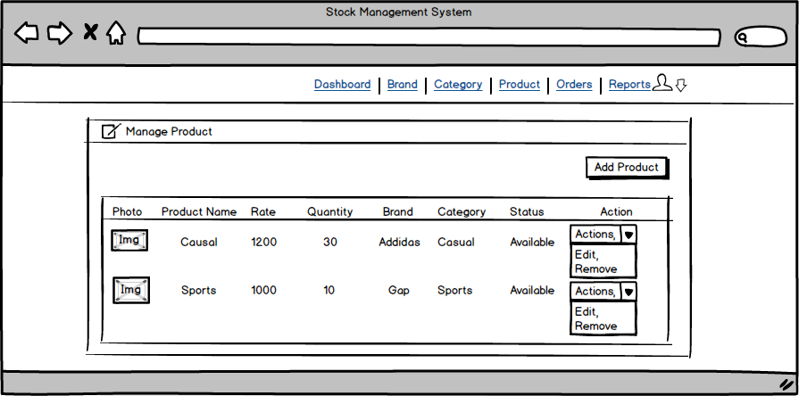

Figure Wireframe Design for Display Product

### Manage Orders

#### Add Orders

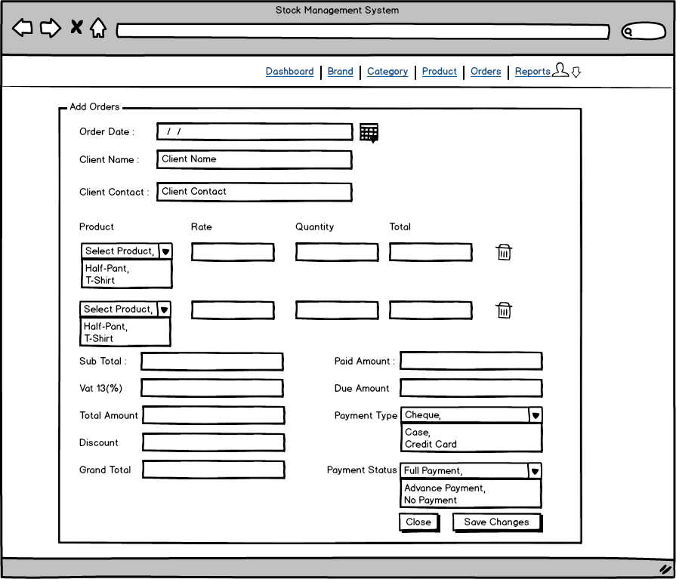

Figure Wireframe Design for Add Orders

#### Edit Orders

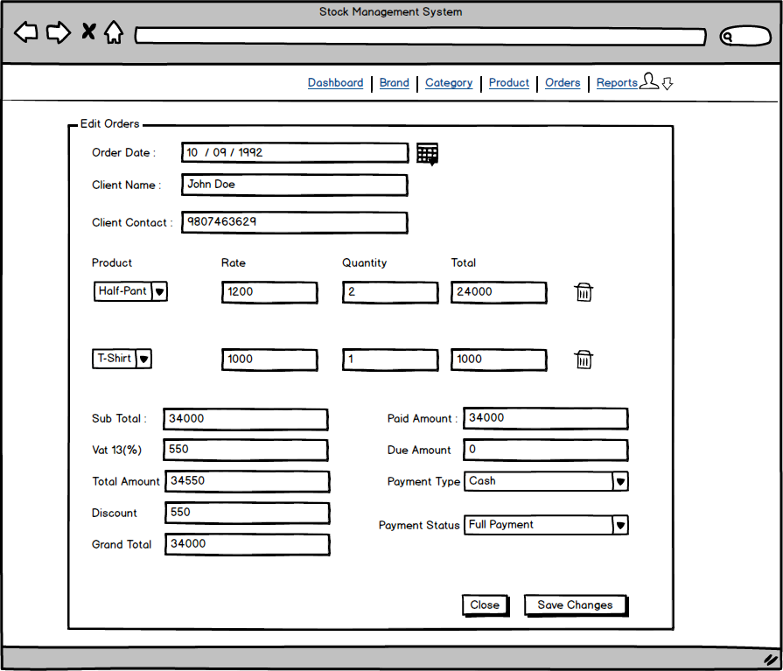

Figure Wireframe Design for Edit Orders

#### Remove Orders

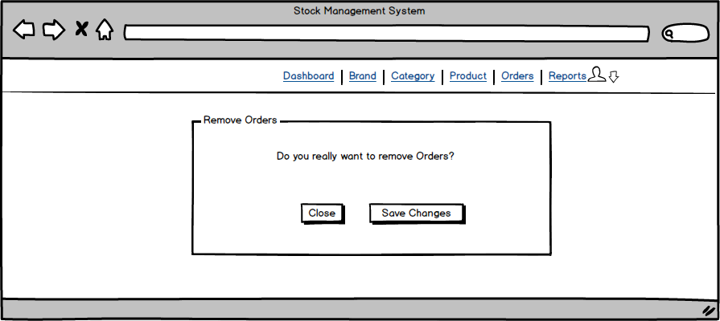

Figure Wireframe Design for Remove Orders

#### Display Orders

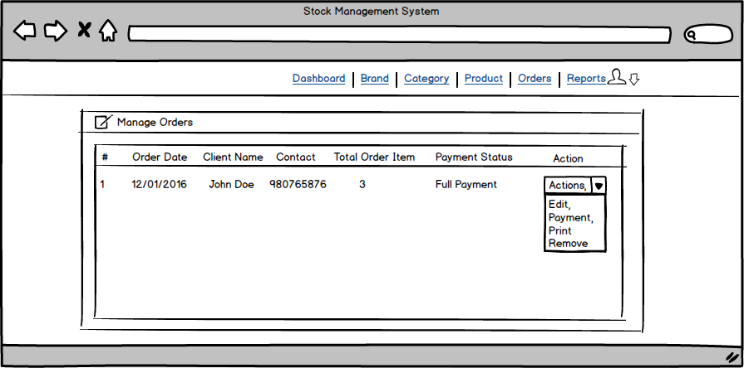

Figure Wireframe Design for Display Orders

#### Payment

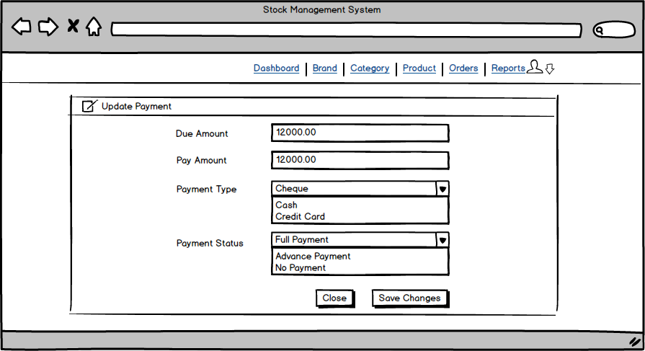

Figure Wireframe Design for Payment

#### Print Orders Bill

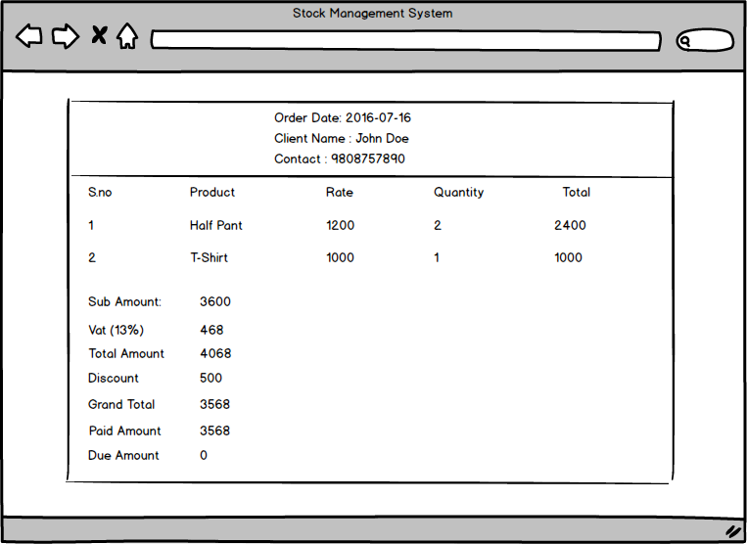

Figure Wireframe Design for Print Order Bill

### Generate Orders Report

#### Generate Orders Report Form

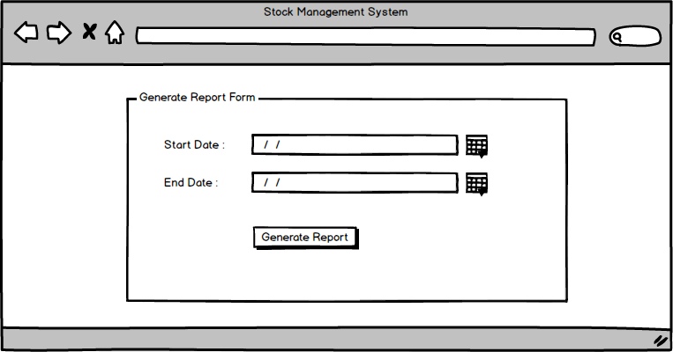

Figure Wireframe Design for Generate Order Report Form

#### Layout of Report

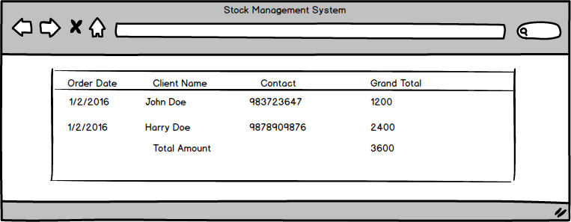

Figure Wireframe Design for Layout of Report

### Setting

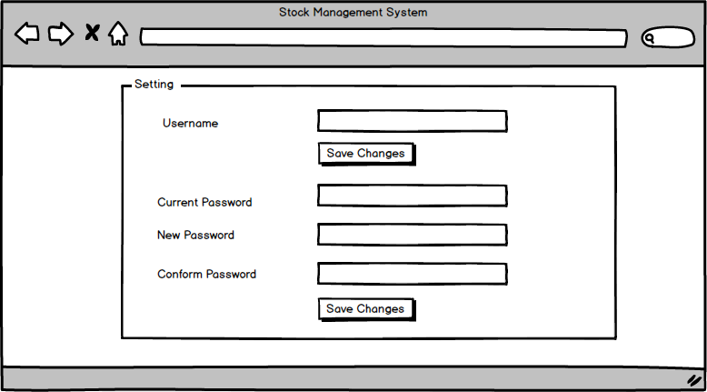

Figure Wireframe Design for Setting

# Implementation

## Screenshots of Final System

### User Login

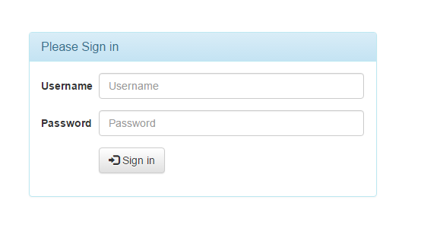

Figure Screenshots of Login

### Dashboard

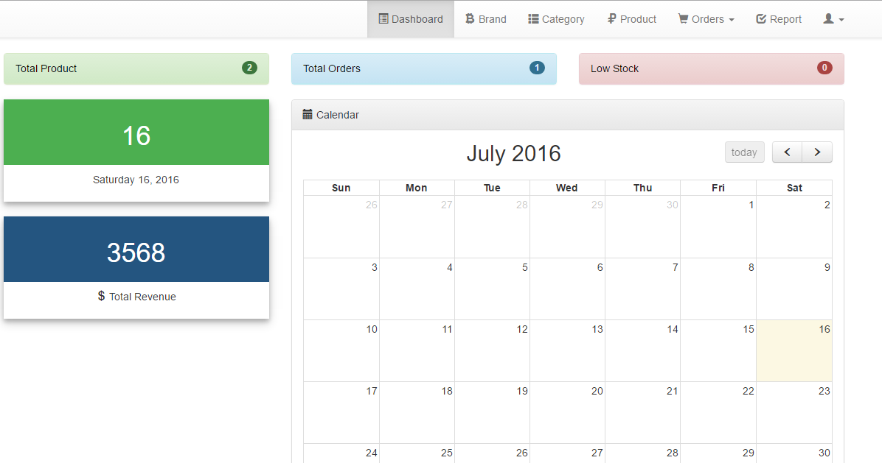

Figure Screenshots of Dashboard

### Manage Brands

#### Add Brand

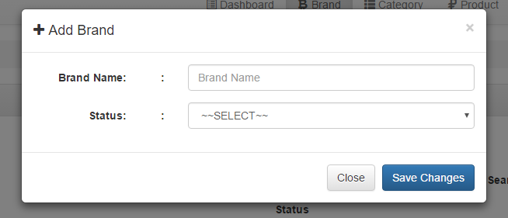

Figure Screenshots of Add Brand

#### Edit Brand

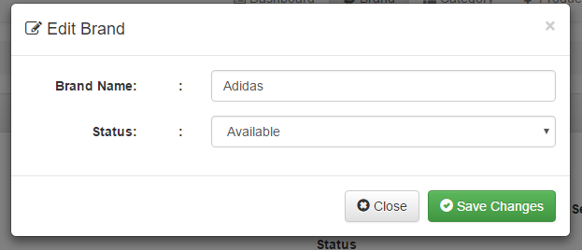

Figure Screenshots of Edit Brand

#### Remove Brand

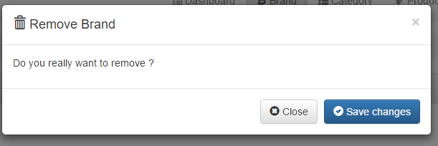

Figure Screenshots of Remove Brand

#### Display Brands

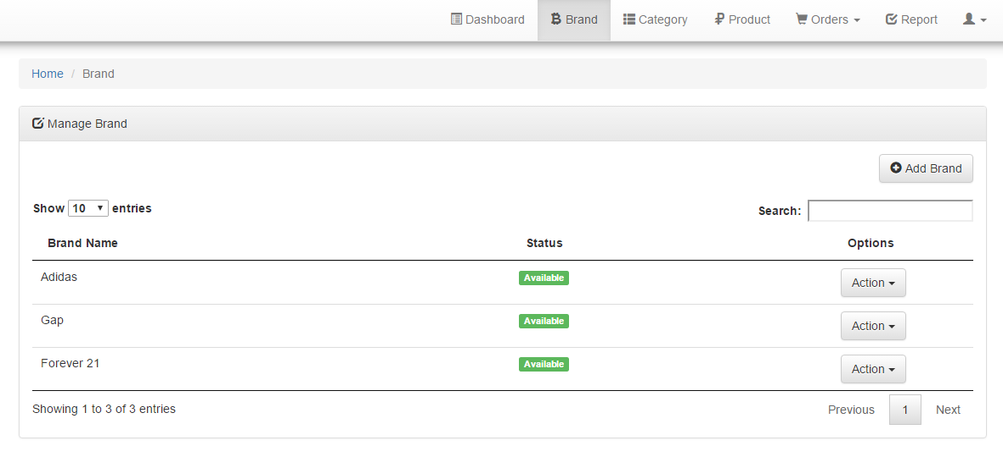

Figure Screenshots of Manage Brands

### Manage Category

#### Add Category

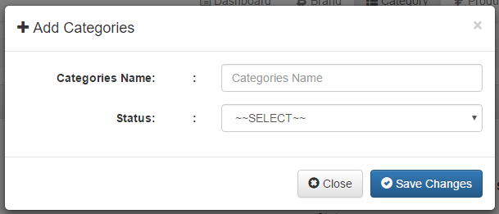

Figure Screenshots of Add Category

#### Edit Category

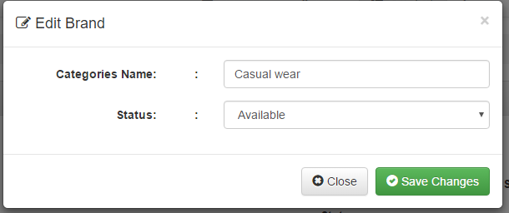

Figure Screenshots of Edit Category

#### Remove Category

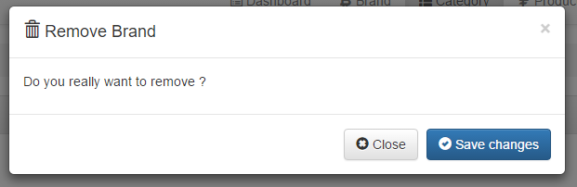

Figure Screenshots of Remove Brand

#### Display Category

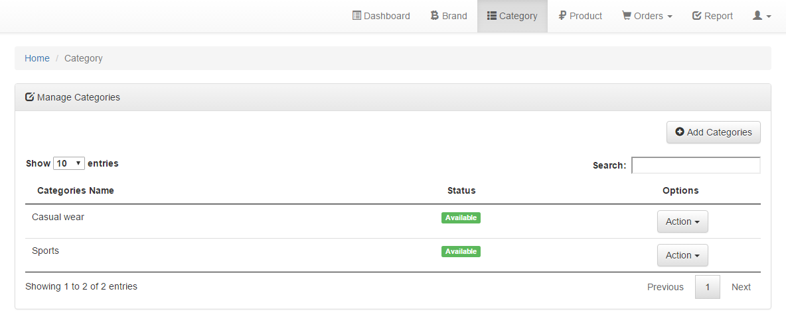

Figure Screenshots of Display Category

### Manage Products

#### Add Product

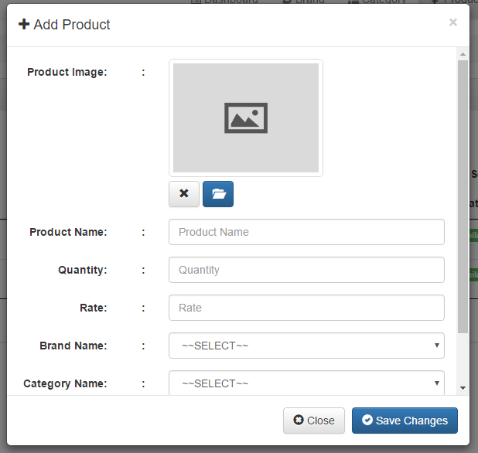

Figure Screenshots of Add Product

#### Edit Product

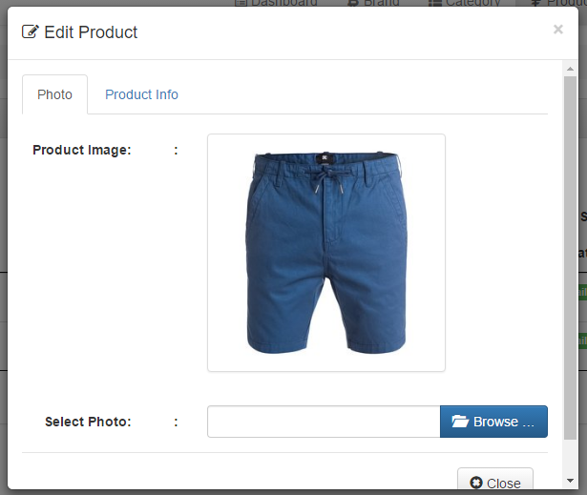

Figure Screenshots of Edit Product

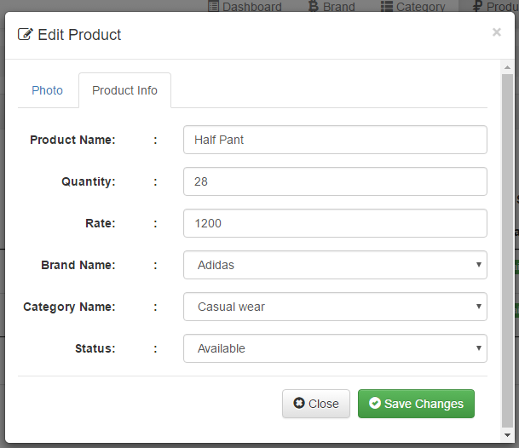

Figure Screenshots of Edit Product

#### Remove Product

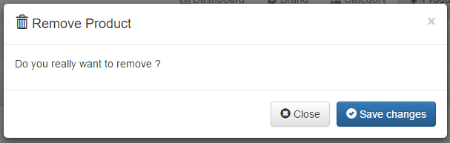

Figure Screenshots of Remove Product

#### Display Products

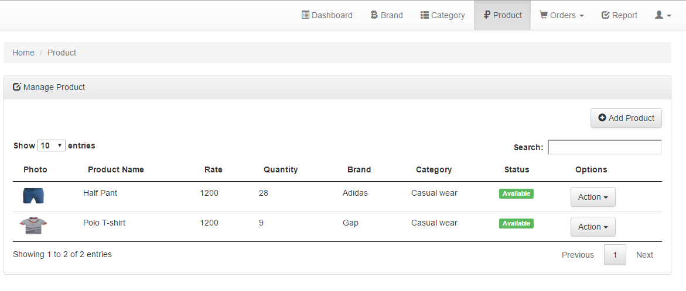

Figure Screenshots of Display Products

### Manage Orders

#### Add Orders

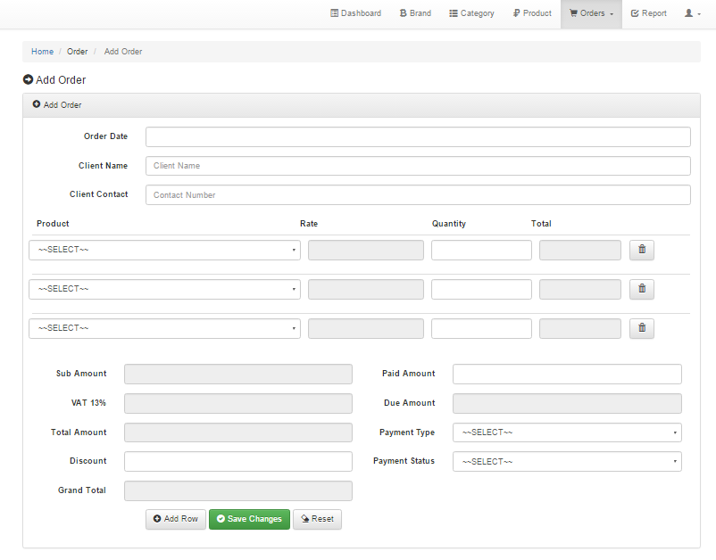

Figure Screenshots of Add Orders

#### Edit Orders

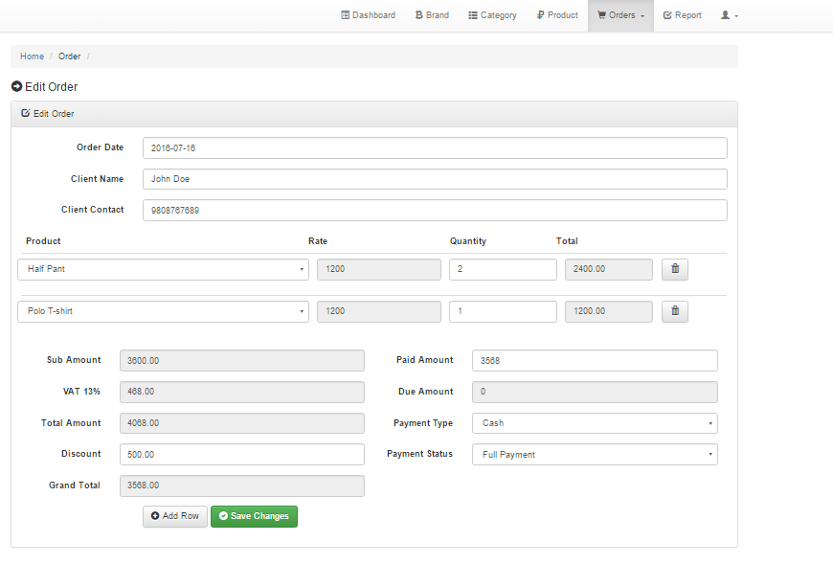

Figure Screenshots of Edit Orders

#### Remove Orders

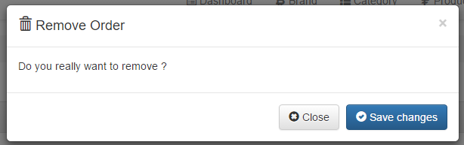

Figure Screenshots of Remove Orders

#### Display Orders

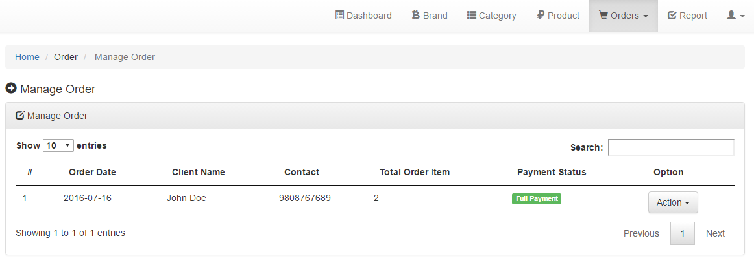

Figure Screenshots of Display Orders

### Generate Orders Report

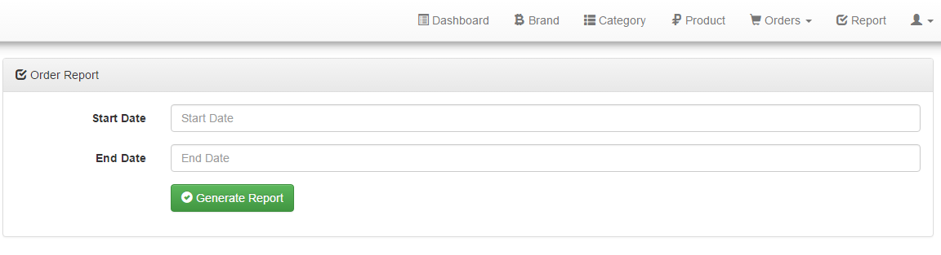

Figure Screenshots of Generate Report Form

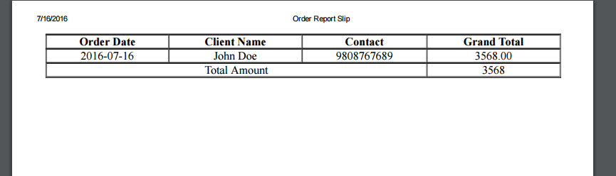

Figure Screenshots of Generate Report Layout

### Setting

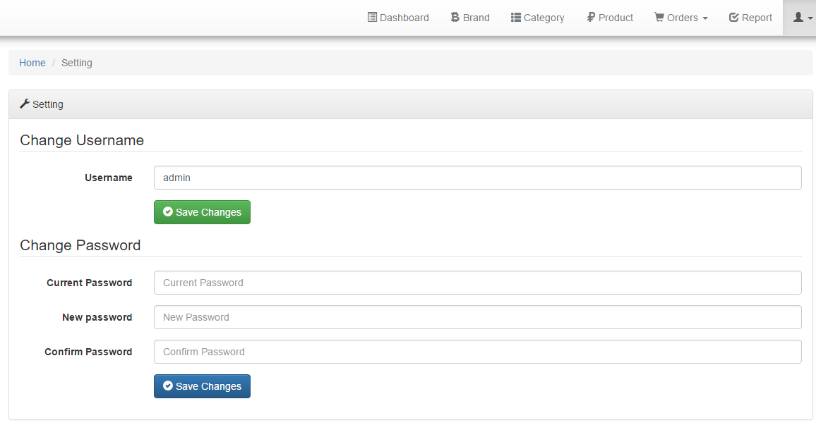

Figure Screenshots of Setting

# References

agilemodeling. (2016, January 16). *Agile Modeling*. Retrieved from http://agilemodeling.com/artifacts/sequenceDiagram.htm

Nishadha. (2012, February 2). Retrieved from Creately: http://creately.com/blog/diagrams/uml-diagram-types-examples/

Points, T. (2016, January 17). *Tutorials Points*. Retrieved from http://www.tutorialspoint.com/uml/uml_activity_diagram.htm

Rouse, M. (2007, March 27). *TechTarget*. Retrieved from http://searchsoftwarequality.techtarget.com/definition/collaboration-diagram

Rouse, M. (2015, January 10). Retrieved from WhatIs: http://whatis.techtarget.com/definition/use-case-diagram

TechTarget. (2005, September 10). *Tech Target*. Retrieved from http://searchsoa.techtarget.com/definition/data-dictionary